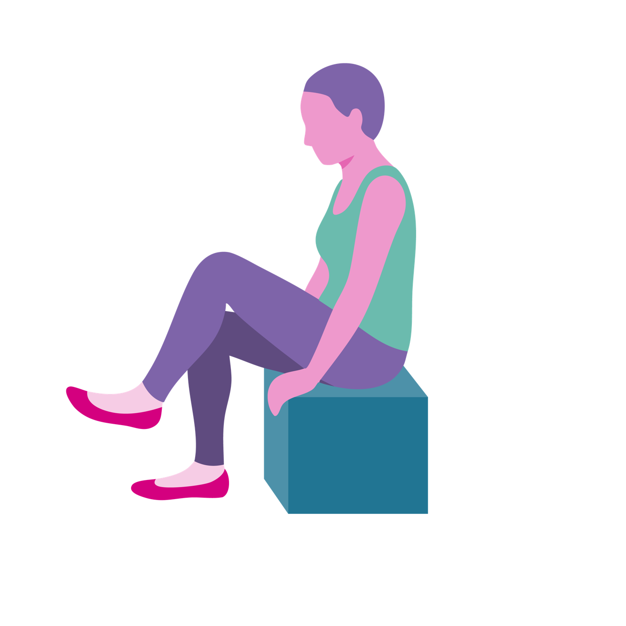

A guide to
Biblical Movement

Based on “A guide to Biblical Yoga” Yvonne Myers.
Biblical Movement has been developed with residents of MHA homes and schemes.

Contents
Introduction - why biblical movement? 3
Before you begin 4-5
Your guide to biblical movement 6
Writing an introduction 7
Starting your session 8
Hymns 9-10
Choosing movements 11
Prayers 12
Ending the session 13
Example - keeping active 14-15
Biblical movement and verses 16
Examples of upper body movement 16-17
Examples of lower body movement 18-19
Examples of movements to help
co-ordination and breathing 20-21
Introduction
Why biblical movement?
Biblical movement can be adapted to help people living with dementia connect to Bible readings and to encourage engagement and discussion. It breaks down a Bible passage by using low intensity and low impact movements, ideal for older adults; however, this can be enjoyed by everyone and can be the basis of Intergenerational worship. The people taking part are able to reflect on meaning and there is an opportunity to express their beliefs and views whilst also giving them the chance to reminisce. Over the years, research has shown that people have different learning styles – auditory, kinaesthetic and visual. Biblical movement is successful because it incorporates all three learning styles:
Auditory – through hearing the Bible passage being read, the movement explained and being given an opportunity to answer questions and share experience.
Kinaesthetic – the session leader and people involved are engaged in physical movement.
Visual – the movements are demonstrated for participants to see. You could set up a table with visual clues that set the scene in the environment, which could be a church, a care home or a community venue.

It can be used with people living with dementia, who we have found often find it helpful in supporting their engagement with scripture. It enables people to feel a part of a community, to reminisce and express any beliefs they have in an open environment. The movement element encourages people to gently move their muscles and improve posture, bringing health as well as spiritual benefits.

Before you begin
Things to consider before leading a session:
Read the whole of this booklet before running Biblical Movement for the first time. You can make notes and prepare reminiscence questions.
-
Visually check the room for hazards, and ensure that there is sufficient space on either side of each chair to move comfortably, without being so far apart that participants feel disconnected from one another.
-
Try to use a room that is light and where a window can be opened in warm weather. Consider closing the door if there is likely to be substantial noise distraction.

If in a care home setting, speak with the senior staff member and explain the activity and ask if any resident has health issues that might be impacted. If the group have taken part previously, you should check before each session whether there have been any significant changes to health.
-
In a care home, there should always be a carer present throughout the session.
-
Before beginning, explain to the group that the session involves doing some movements and that participants should only do movements that feel comfortable. It is good practice to remind people of this throughout the session, especially when moves involve arms or shoulders. Remind people that if they feel any pain or discomfort from the movements, they should stop immediately.
-
You may want to have a flipchart or whiteboard available to note down any points of discussion.

Your guide to biblical movement
Choosing a scripture passage

Choose something familiar and well-known
Take a congregation/group centred approach
Any Bible verse can be used and adapted for Biblical Movement; you could choose to follow the Liturgical Year and use Biblical Movement within a service.
People with more advanced dementia may benefit from passages that lead up to key celebrations, as these will be familiar, for example Easter, Harvest and Christmas. Biblical Movement can be multi-generational, consisting of sessions to fit in with the school term. Choosing well known biblical stories such as Noah’s Ark or Jonah work well and can bring back memories of childhood. Some passages are harder to adapt for Biblical Movement – passages that are full of theological ideas such some parts of the epistles can be challenging!
Choosing a suitable translation and paraphrasing where necessary will improve the delivery of the session and its impact. As dementia progresses, people living with dementia can lose the understanding of less commonly used words, so choose words that will be familiar; substituting words may make engagement with the passage and the movement better understood.

Writing an introduction

Introduction to the theme or story
Welcoming and inclusive
Most church services start with a welcome and this is an opportunity to acknowledge everyone present and make everyone feel welcome. If you haven’t used Biblical Movement before with the group then this is the time to explain the Order of Service and introduce the theme or teaching of the day. The introduction should be concise and create interest for the session ahead. Before your introducing your theme, take a minute to ask how people are feeling – this can be a way of picking up on any aches or pains.
Here is an example of an introduction to a Biblical Movement session on The Last Supper:
“There is nothing like sharing a meal with family and friends. As we approach Easter the adverts on television are advertising families getting together for Easter Sunday dinner. In Jesus’ time, people were preparing to eat the Passover Meal and as with all good social meal times there were some interesting conversations.”

Starting your session
Warm up – Singing together helps to create a sense of belonging, and many people living with dementia find that music is helpful and enjoyable, so you may want to start by singing a well known hymn. There is more information about using hymns effectively later in this guide.
Main exercise – The Bible reading with actions

Read the passage once, demonstrating actions
Read again, so all can try the actions
Once the passage has been read using the actions at each of the appropriate points, you can explain that you will read it again and people can repeat the movements with you if they wish. It can be helpful to have one person reading, and another demonstrating the actions (in a larger church, you may want two people demonstrating the actions).
Throughout the session, walk around and engage with participants on a one-to-one level, encouraging them and showing them how to do the movements. Allow the participants to copy you. Always allow them to make the movements themselves, adapting them to make them comfortable if necessary.

Hymns

Choose well known hymns
Move around the room to increase engagement
Singing a hymn at the start of a service or biblical movement session is a great way of bringing people together. Hymns during the worship can support participation. Much research has been done into the benefits of singing for mental health and listening to music together has been found to help people feel connected to each other and feel part of a community.
Move around the room while singing and if possible sit for a few moments with anyone who would benefit. Singing with someone living with dementia can encourage engagement and participation.
• Questions and reflection
• Reminiscence & reflection
• Reminiscence questions
• Spiritual reflection questions
• Listening to shared experiences and faith
Take one line of scripture at a time and write some spiritual reflections and reminiscence questions for each. Reminiscence questions are those that explore past experiences and events.

Keep the questions short and concise, such as:
• Have you been on a boat?
• Have you picked fruit from a tree?
• Have you held a baby in your arms?
• Where do you like to pray?
It will be more effective to limit the use of questions that require short-term (recent) memory as this may be difficult for some people to respond to, for example rather than saying “did you enjoy last week’s session?” ask in the moment questions around feelings such as “are you enjoying this?” or “how do you feel?”
Engage with people by walking around the room and asking people reminiscence questions that are connected to that line of scripture. Make eye contact and sit alongside them. It may also be necessary to repeat a question a few times and be patient about getting a response. Listening to people’s experiences shows that you value what they have to say and they will be more open and trusting about sharing more personal thoughts about God and their faith. It may not always be possible to understand their response, but if you are able to pick up on one or two words that they have said, you will be able to repeat those words back. Reflecting back what someone has said shows that you are listening and will create an atmosphere where they feel comfortable.
Choosing movements

Try to incorporate a range of movements
Aim for 10-15 movements per session
Repeat the same movement if a word or phrase repeats
All of the movements are designed to be done in a seated position.
Try to incorporate some lower body movements, that is moving feet and legs, and some upper body movements involving arms, hands and neck. Avoid keeping arms above the head any more than just briefly. Tailor the slow and easy movements to suit the scripture passage. By incorporating a range of movements, Biblical Movement benefits body, mind and spirit and gives people an opportunity to take part in an “exercise” that is extremely inclusive of all abilities.
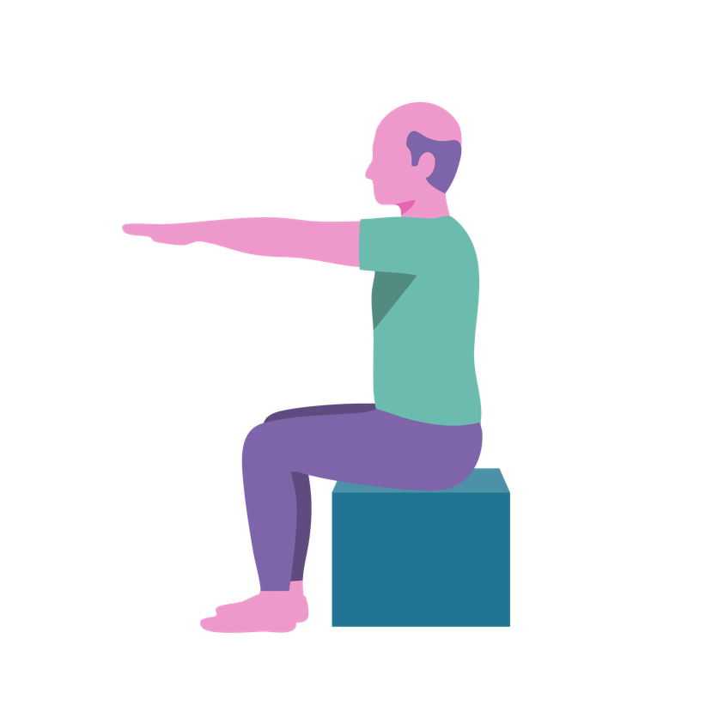
There are examples of movements along with biblical references later in this booklet.

Prayers

Select a few, short, familiar prayers
Include personal intentions (for example, prayers for the families and friends of those participating)
Try Taize or similar repetitive chants interspersed
with short prayers
Prayer is an important part of the Christian life; there can be times in life when we feel drawn to prayer and at other times of our life, prayer can be difficult. Be guided by the Spirit in prayer and let those opportunities be moments to share prayer together.
Help bring people together and connect them with God through mediation or music. There may be opportunities when silent reflection can be a fruitful experience. Familiar prayers act as a foundation for people; the Lord’s Prayer is a great way to engage everyone of all ages, familiar with the prayer. In a context where different languages are spoken, you can invite people to pray the Lord’s Prayer in whatever language comes most naturally to them.
The words, rhythm and tone of a familiar prayer like the Lord’s Prayer can help people living with dementia to engage in dialogue with God. You may want to incorporate Biblical Movement into the Lord’s Prayer to enhance its meaningfulness.
Ending the session

Be short and concise
Include memories and experiences
To finish the session, include references to contributions people have made in the session. It is important that everyone feels valued and welcome in the sessions. Touch on personal memories and experiences that link to the Bible verses and movements used in the session.
Cool down – a time of reflection, meditation and/or prayer.
• Use counting for breathing techniques and imagery from the Bible reading as part of the meditation.
• Refreshments may be offered before further discussion.
• You could also use a whiteboard to write down some of the key thoughts and reflections from the session.
Depth of discussion will be different for each session. After discussion, it's a great time to get feedback on the session. Some things to focus on for future sessions are: How easy were the movements? Did people enjoy it? Was there anything that they remembered?

Example - keeping active
Being active can reduce the risk of falls and can aid our sleep.
Hymn: Be still my soul
I Corinthians 6:19
“Our bodies are a temple. (What does this mean? How should we treat our bodies? How can we take care of our bodies? Other people should treat our body with respect and dignity and we have responsibility to speak up for ourselves”

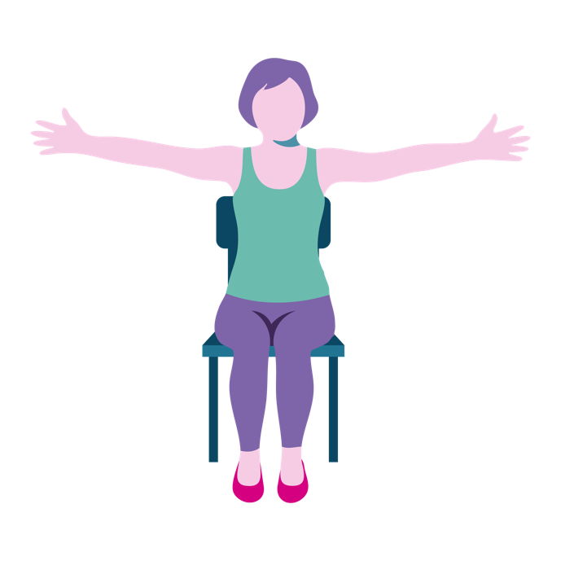 | Hold arms out to the side and hold for 5 seconds.  Be aware of the space that your body is in. Can you feel the chair surrounding you, can you feel the clothes on your skin? Take notice of your breathing.

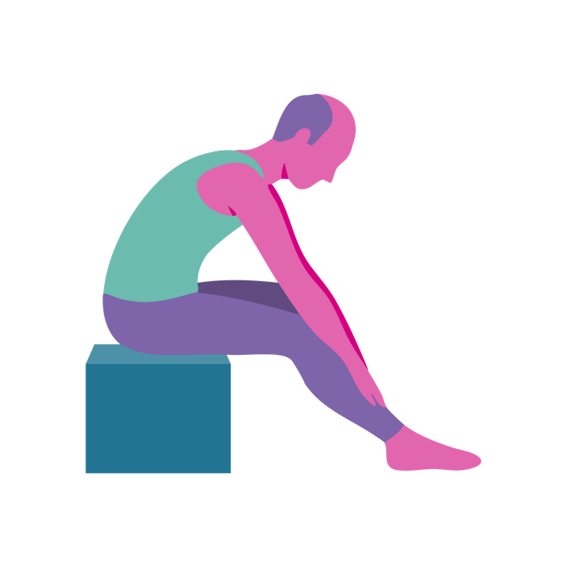
“The Holy Spirit resides in our bodies. (What is the Holy Spirit? What makes us different from animals? The Holy Spirit is a gift from God).”

Place hands on knees and slowly move hands down legs as far as comfortable.

“God wants us to look after our bodies. Regular exercise helps us to sleep better, feel less stressed, reduces aches and boosts our immune system, and gives us a better appetite.”

Prayers
“Lord, help us to focus on what we can do and not on what we can’t do.
Give us encouragement each day to take part in activities that help our wellbeing.
Help us to accept that you love us for who we are and what we can offer today.”

Biblical movement and verses
Over the next few pages are some examples of Biblical Movement actions for upper body, lower body, co-ordination and breathing techniques. Some extracts from the Bible aim to show how a movement could be connected to a line of scripture.

Examples of upper body movements

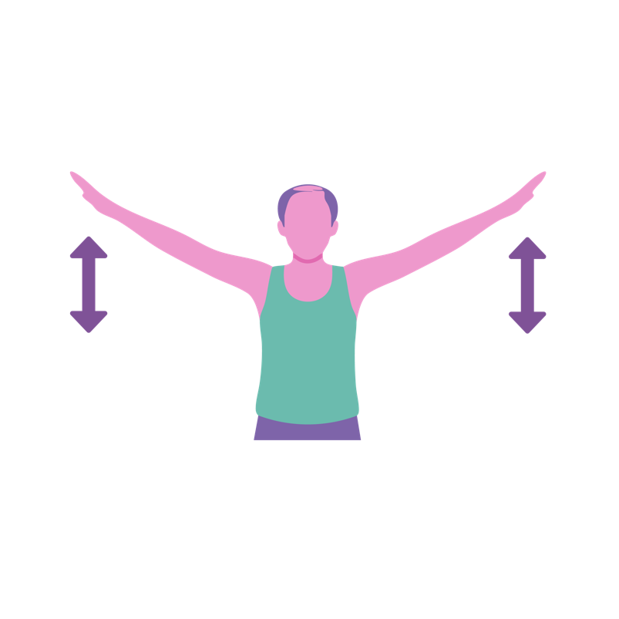 | Place arms to the side and  raise up and down as if  you had wings.  Matthew 4:6 “He will command his angels”  Luke 1:27 “The angel went to a virgin”  Psalm 55:6 “If only I had wings like a dove.”
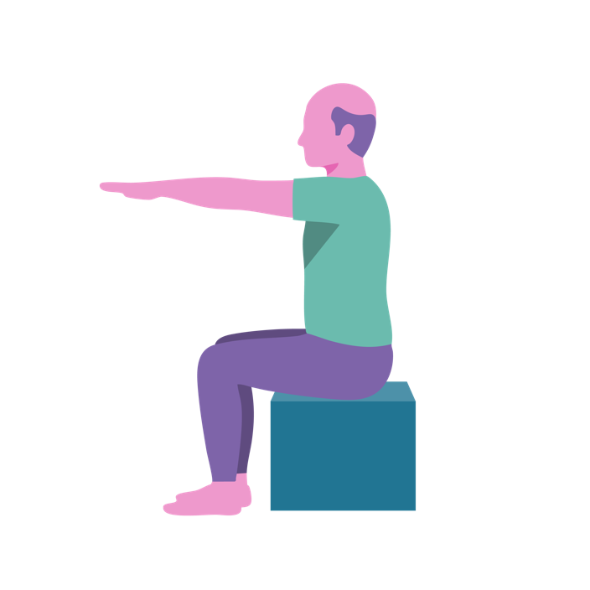
Raise arms up to shoulder
height.
Mark 14:42 “Rise. Let us
go!”

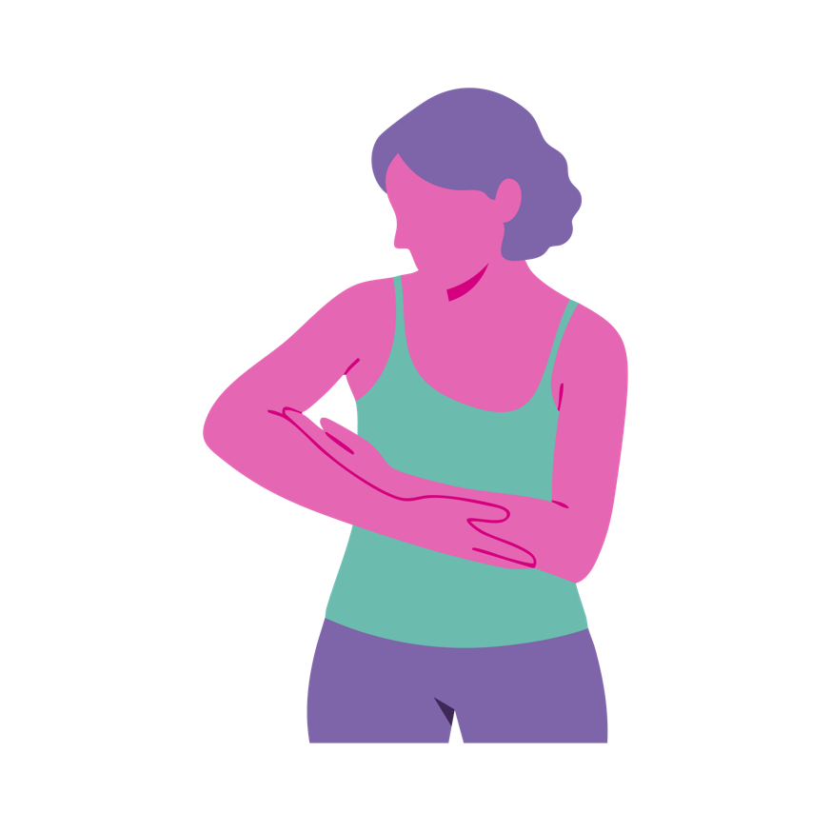
Place arms together and sway from left to right to loosen the shoulders.
Luke 2:7 'She gave birth to her firstborn, a son.'
Exodus 2:3 'She placed the child in it.'
1 Kings 3:26 'Give her the living baby!'

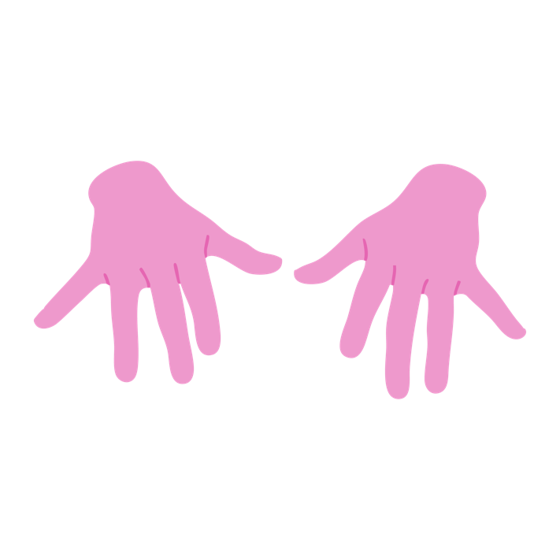
Hold hands out in front and move fingers (exact movement can be adjusted to suit verse).
Mark 6:36 “Send the people away”
Psalm 80:13 “Insects from the fields, feed on it”

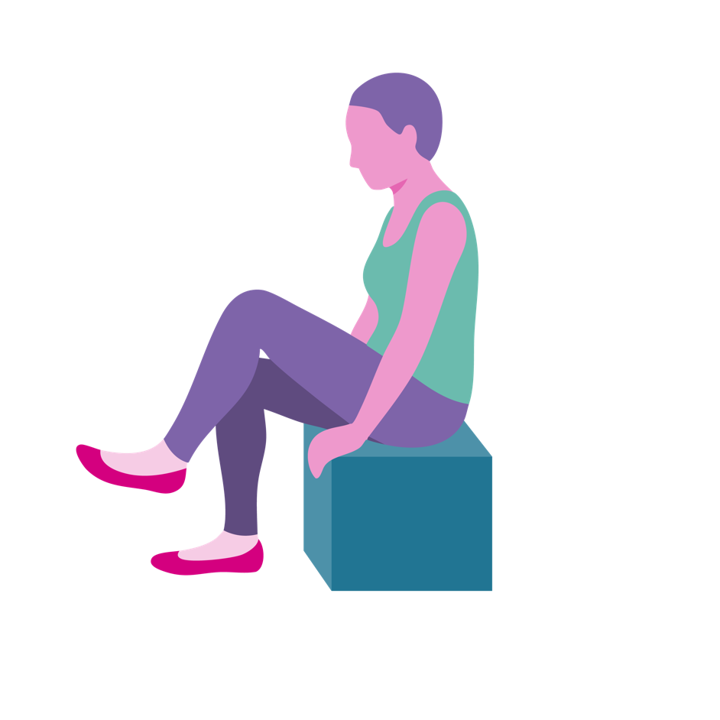
Examples of lower body movements
Lift one leg, hold and relax, then repeat with other leg or march legs
on the spot for a few seconds.
Luke 2:15 'Let's go to Bethlehem.'
Exodus 14:29 'The Israelites went through
the sea.'

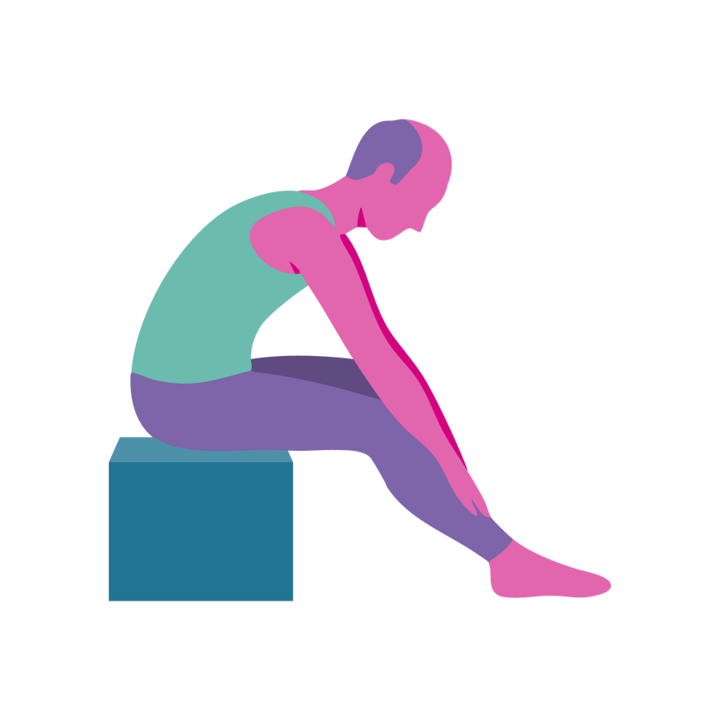
Place hands on knees and slowly move hands down the legs towards the feet as far as comfortable.
Matthew 2:11 “… they bowed down and worshipped him.”
Genesis 3:19 “…dust you are and to dust you will return.

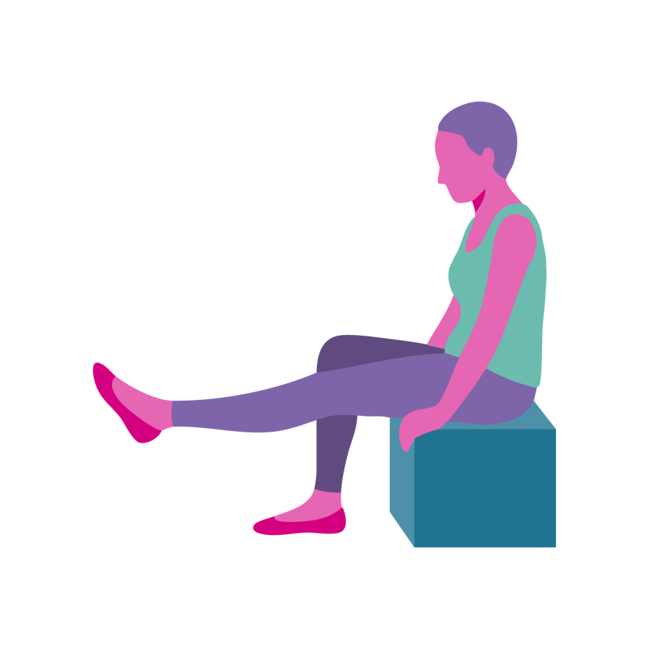
Raise one leg at a time and hold for a few seconds if comfortable, relax and repeat with the other leg.
Acts 3:7 “…the man’s feet and ankles became strong”
Philippians 1:7 “W… whether I am in chains...”

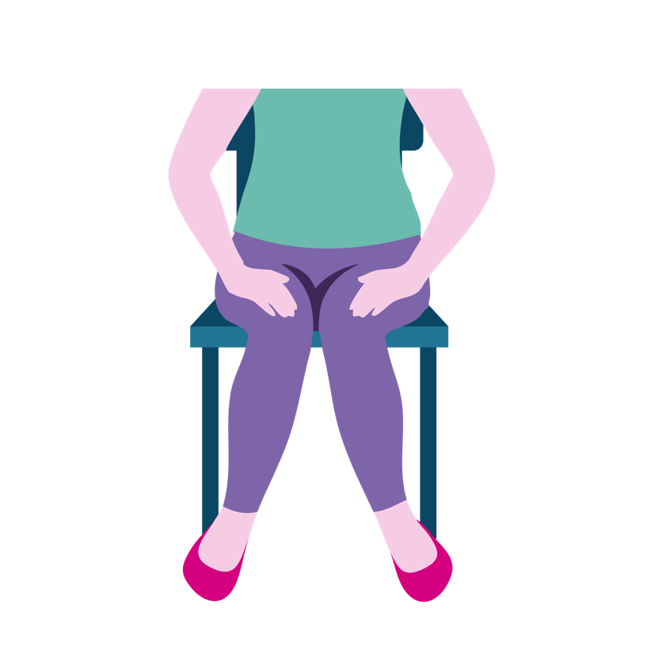
Sit with legs slightly apart and bring knees in together and repeat.
Daniel 5:6 'His legs became weak and his knees were knocking.'
Hebrews 12:12 'Strengthen your feeble arms and weak knees!'

Examples of movements to help co-ordination and breathing
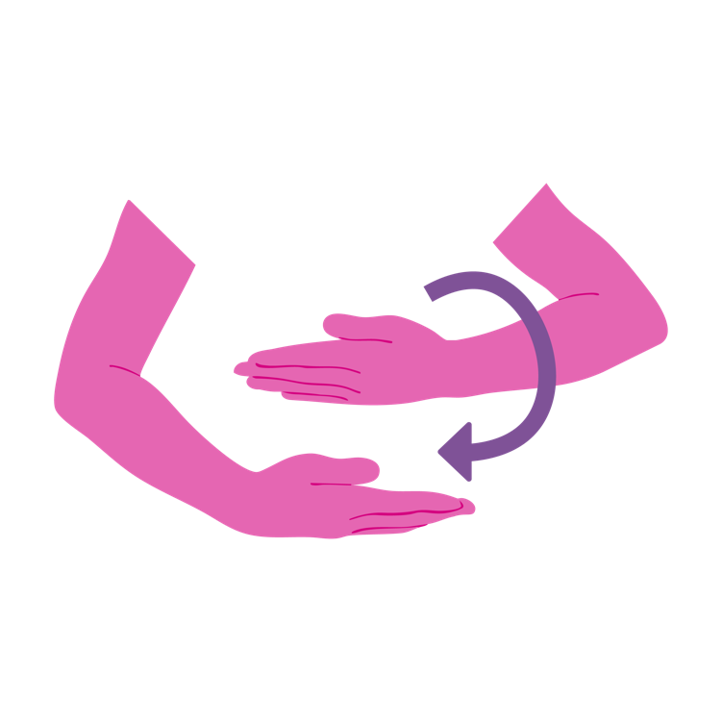
Place one arm over the other and rotate around each other, one way then the other.
John 19:40 'Two of them wrapped it, with the spices.'
Luke 2:7 'She wrapped him in cloths.'

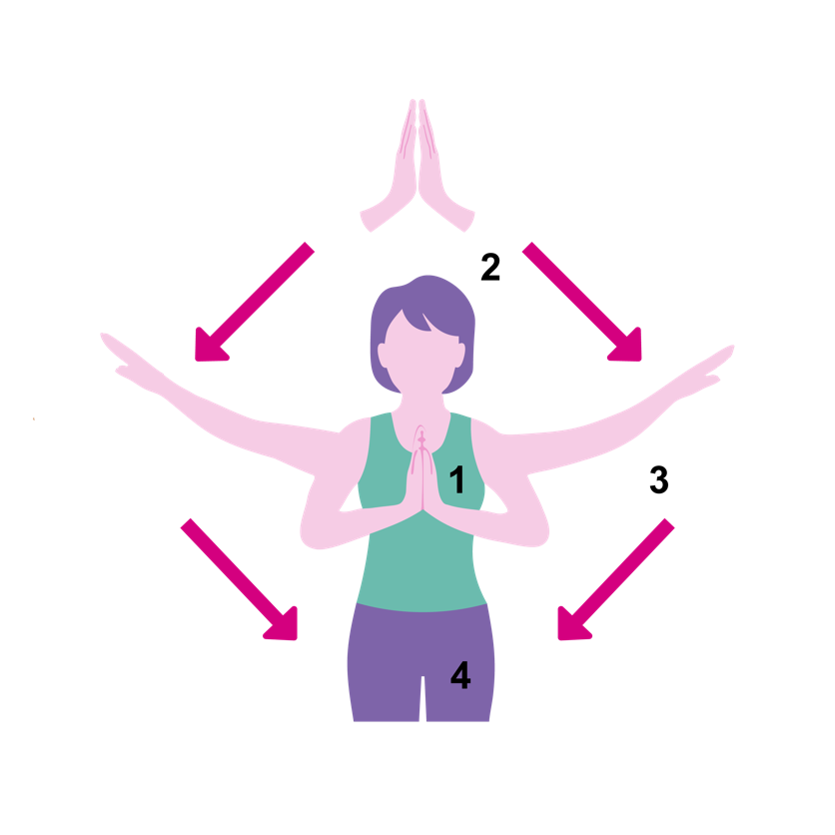
Start with hands in prayer position – breathe in and raise hands in that position in front of your face, then as you breathe out move hands down together then apart, out to your sides.
Acts 2:11 “…the wonders
of God.”
1 Cor 13:13 “And now faith, hope and love remain…”

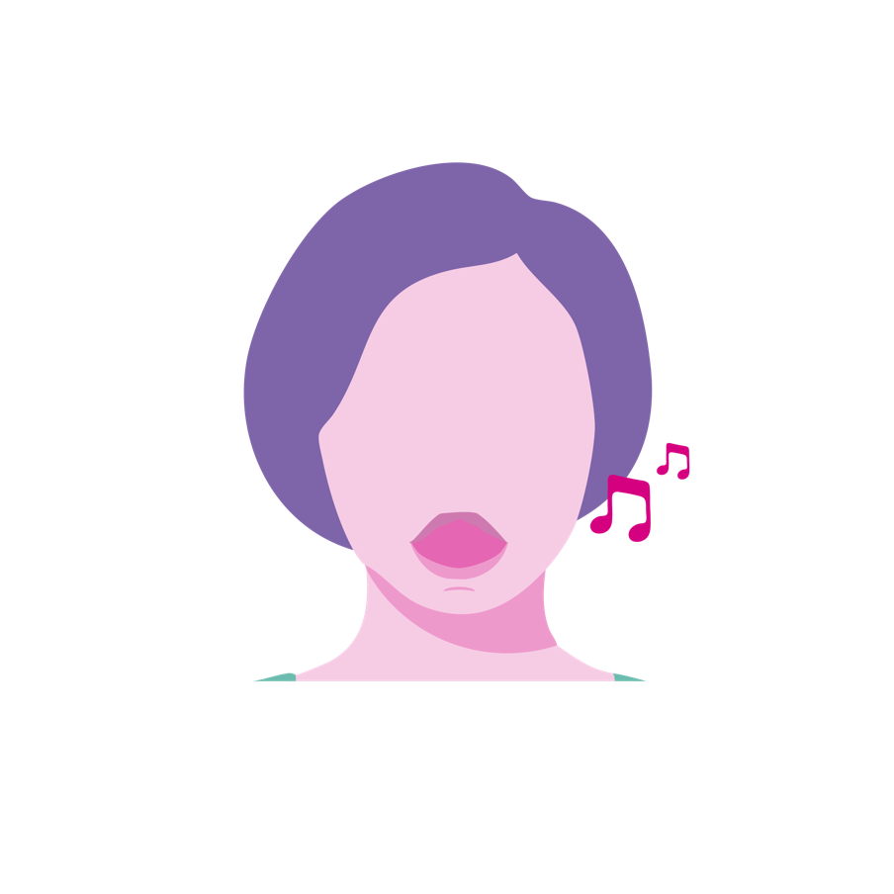
Take a deep breath and sing 'la la la' for as long
as possible.
Luke 1:64 'His mouth was opened and his tongue set free.'
Joshua 6:16 'Shout! For the Lord has given you the city!'
Psalm 13:6 'I will sing the Lord's praise...'

