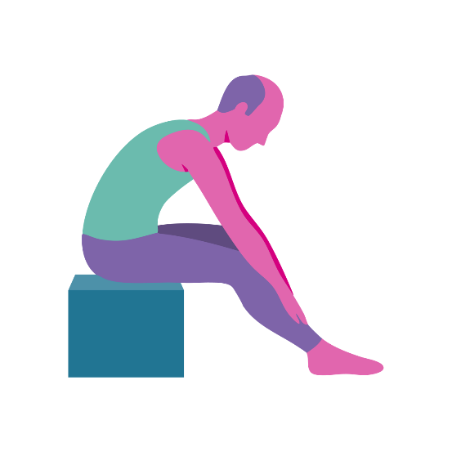
Biblical Yoga

Written and developed by Yvonne Myers
- Chaplain at MHA Amathea.

Biblical Yoga
Foreword
Biblical yoga is designed to help people with dementia to hear the word of God and enable discussion. No doubt we have all experienced the occasion when we have attended a Service and later in the day were unable to remember what the reading was. There is a need to help people with dementia to hear the readings in a way that is helpful for them by delivering it in a way where they can be connected to the scripture in that moment. The purpose of Biblical Yoga is to help people with dementia to feel connected to biblical passages through interaction with the story. It helps people with dementia to remain focused on the scripture in that present moment through the use of movements that engages them with the scripture. This offers opportunities for spiritual reflection and reminiscence.

Movement and exercise are an important part of our wellbeing. Breathing exercises increase oxygen levels in the body and have a calming effect. The movement and laughs we have while exercising release the happy hormone endorphin which helps residents to feel happier and can reduce pain. The exercises in each session ensure that we are exercising our lower and upper body, using coordination and breathing exercises.
The regular exercise helps residents to stay mobile, more alert and reduces the risk of falls. Biblical Yoga is low impact and low intensity designed for older and frailer adults and for those with disabilities.

Before you begin
Ensure Moving and Handling training is complete.
-
Complete a Risk Assessment (ask Activities or your line manager for assistance).
-
Familiarise yourself with residents pre-assessments.
-
Visually check the room for hazards. The chairs should be set up around the edge of the room with ample space at each side but not so far away that people feel disconnected from each other.
-
Try to use a room that is light and where a window can be opened in warm weather. Consider closing the doors to the corridor if there is likely to be substantial noise distraction.
-
A carer must be present during the session. You should always ask the Senior Carer if there are any changes to residents’ health that you need to be aware of.

Ensure that you speak to each resident before starting the session to ask how they are feeling, whether they are in any pain today and to ask if they would like to take part.
-
To begin the session, explain that we will be doing some movements together and that we should only do what feels comfortable. Residents with dementia will need to be reminded of this throughout the session, especially when moves involve arms or shoulders.

*Medical pre-assessments are in Care Plans. Consent forms for taking part in Activities are in the Care Files of those in Care Homes and Nursing Homes. It is useful to have an understanding of your residents mobility issues so that you can help tailor a movement to their ability. Importantly during these sessions you will not be moving anyone.

When you have a new resident you will visit them
1-2-1 and explain who you are and the groups that you organise. This gives you an opportunity to explain the benefits of remaining active while explaining risks (not doing movements that are uncomfortable and taking into account any medical problems).

Begin the session
Warm up – increasing oxygen intake by singing a hymn. You could listen to a hymn being sung, join in the well known verses and clap hands or use musical instruments. The level of warm up will depend on those you are working with. Biblical yoga is designed around the needs of the residents and I have tailored it to suit the needs of older adults in a seated position.

Main component – the bible reading with the actions. There are opportunities for discussion and reminiscence as you read slowly like Lectio Divina and there are opportunities for rest between movements. Once the passage has been read you explain that you will read it again and residents can repeat the exercises with you if they wish.

Demonstrate to residents how to do each movement. Show them how they can do an easier version of the movement. Acknowledge residents for their participation. Correct any bad posture and praise them for their participation. You should be able to notice when a resident has made a huge effort even if the movement was very small. Recognising that achievement for that resident is vital in motivating and encouraging residents to continue engagement.

Throughout the session I advise walking around and engaging with residents on a one to one, showing them how to do the moves and making eye contact. Simply holding out your hands towards them will in most cases make the person you have eye contact with, hold out their hands towards you. You may swing your body a little and this will help them to react by swinging their arms. At no point have you pulled them or moved them but you are moving with them. You may also need to support residents one-to-one by indicating to them that you would like them to uncross their legs for a particular exercise. Remember that you may need to repeat instructions a few times as reaction and response times decrease with age.

Each session has a title followed by the text which have been adapted from The New English Bible. The words highlighted are the words to do movements to. Pictures of each movement with a description are found at the end of each session. There are suggestions for how many movements to do but each Chaplain will need to consider the ability of their group and gauge how many repeats are appropriate for their residents. There are between 10 and 15 movements per session.

The first session delivered will be new to everyone. Do not worry if residents do not engage with all the movements. They are free to choose which movements they would like to do and at liberty just to watch. As you move through the weeks you should start to notice residents performing the movements more freely. You may like to explain why a movement is beneficial (muscle strength, joint movement, ease neck or back pain, coordination). As the weeks move on you also will become more familiar with the movements and more relaxed about the delivery.

Cool down – A time of reflection, meditation and/or prayer are all good ways for residents to end a session. Use counting for breathing techniques and imagery from the bible reading as part of the meditation. I offer refreshments and then we discuss the scripture further.

The Carol Service will showcase some of the movements you’ve been working on. Although I often do Biblical Yoga as part of a Worship Service it is not necessary to do so. The passage is read slowly and there are opportunities as you go along for discussion, reminiscence and spiritual debate. Biblical Yoga can be enjoyed by people of Christian faith and none when done as a stand alone session. I have included suggested prayers, hymns and points for discussion. Depth of discussion will depend on the residents in your session. The aim is for residents with dementia to feel part of the Gospel and feel truly connected to it at a level that suits them.

Feedback
It is best to ask residents how they feel about the movements and whether they find them hard, easy and whether they find it enjoyable.

Session One for Advent Biblical Yoga
Baby John and Mary’s Visitation
Luke 1:5-38, 46-66.
King – Imagine holding a crown and lifting it up above head. Hold and lower crown back onto head. Repeat twice. (For those who cannot lift their arms above head simplify movement by holding crown in front of them).
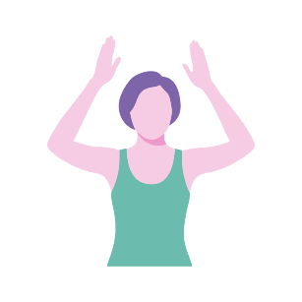
In the time of King Herod (who is our Queen?) of Judea there was a priest named Zechariah and his wife Elizabeth. They wanted a child but they were now very old.

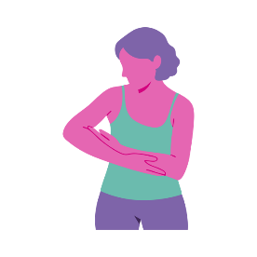
Child – Rock the baby – gentle shoulder movement.
5 swings.
Zechariah went to the temple and an angel of the Lord visited him. When Zechariah saw the angel, he was gripped with fear (Discuss how you would feel if you saw an angel). But the angel said to him: “Do not be afraid, Zechariah; your prayer has been heard. Your wife Elizabeth will bear you a son, and you are to call him John. He will be a joy and delight to you, and many will rejoice because of his birth, for he will be great in the sight of the Lord because he will make people prepared for the Lord.”

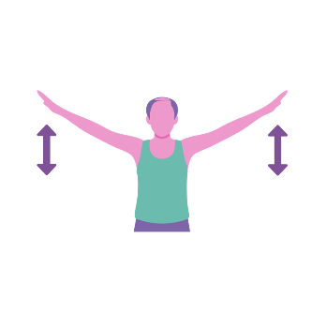 | Angel wings – Slow movements up and down  5 times.

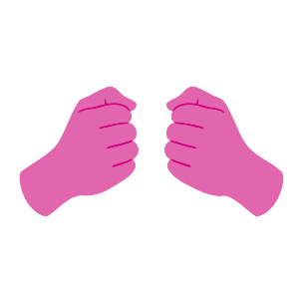 | Gripped hands – Grip and release twice.

Prayer position – Breathe
in and raise arms above
head and breathe out as you lower arms to the side. Do this twice.
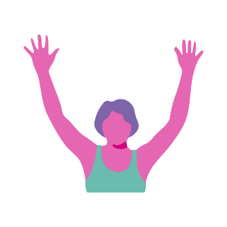
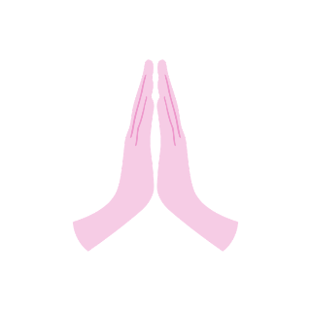
Rejoice – Arms above head and wave arms slowly like branches in the wind.

Zechariah questioned the angel, “How can I be sure of this? I am an old man and my wife is well along in years.” The angel said “Because you doubt you will not be able to speak until the child is born.”
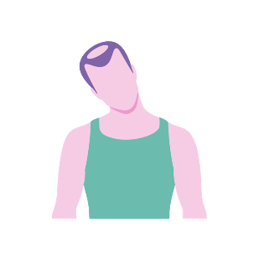
Zechariah went home unable to speak.
Questioned – Lean head slowly to the right and slowly to the left twice.

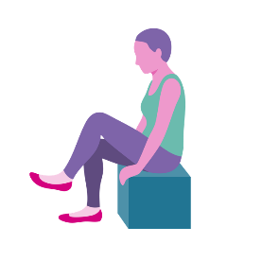
God had sent an angel to tell Mary she would have a baby who would be the son of God. Mary went to see her cousin Elizabeth. When Elizabeth heard Mary’s greeting, the baby leaped in her womb. (Talk about babies kicking in the womb, experiences of pregnancy, old wives tales ‘if you have heartburn the baby will have hair’, how babies recognise voices in the womb). In a loud voice she exclaimed: “Blessed are you among women and blessed are you for believing in God’s promise.”
Went – Leg lifts. Remind residents to uncross their legs. Raise one leg at a time and hold for 2 seconds. Relax and then raise the next leg and repeat twice. For those with greater mobility we usually count out 10 lifts.

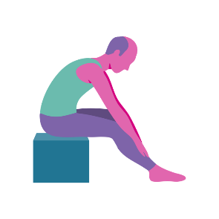
Leaped – Hands on knees and move hands slowly down legs as far as is comfortable. Slowly move back to seated position.

Mary was so happy she sang a song.
Elizabeth had her baby. What will you call him?” everyone asked. “He is to be called John.” “But no one in your family has that name”. (Discuss family name. How important is it to choose a biblical name? Did family like the names you chose for your children?) Zechariah wrote down “His name is John.” And immediately his mouth was opened and his tongue set free. He praised God.
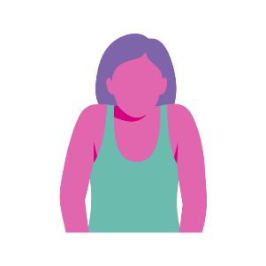
What – Shoulder lifts. Lift shoulders up to ears, hold and relax

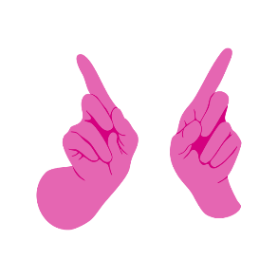
No one – Hold arms straight out in front and wag index finger.

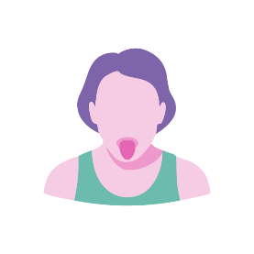
Open and Tongue – Lion face – Stretch the face by opening eyes wide and sticking tongue out. Make the sound ‘lalalala’.

The magnificat could be played during quiet reflection or while refreshments are being served.

Prayers:
- Zachariah had prayed for a son and when God finally answered his prayer it came as a shock. Lord, help us when we are shocked by news and events in our lives. (There may be stories in the news that have touched people or more personal events such as a recent fall that you can adapt this prayer for).

- We pray for women who are pregnant. We pray for the health of new mums and babies. (Perhaps residents have news of new babies in their families).

- We thank God for the safe delivery of our babies and pray for those of us who have lost children. Lord, comfort us in our grief.

- We praise God for all the blessings we have received in our lifetimes. We thank God for those moments of joy and happiness. We pray that we may share love and peace with others this Advent.

Suggested Carol: O come, o come Emmanuel.

Session Two for Advent Reflection
A message for Joseph
Matthew 1:18-23 & Luke 2:1-6

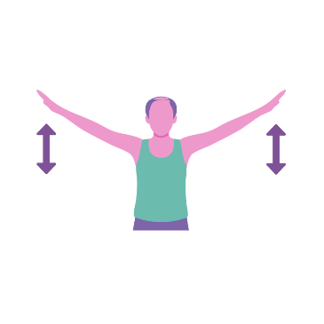
An angel had told Mary she was to have God’s child and name him Jesus. Joseph was engaged to Mary and was not pleased. (Discuss what Joseph must have been feeling or what he suspected). One night an angel appeared to Joseph in a dream and said ‘do not be afraid. Mary will bear a son and you shall call him Jesus’.
Angel wings – Slow movements up and down
5 times.

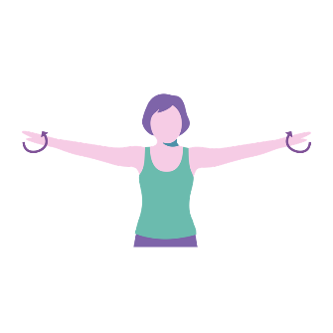
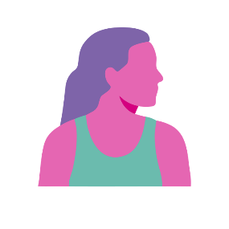
Joseph agreed to marry Mary and look after the special baby (Discuss what things we need to do to look after a baby? What preparations did you make? What roles did fathers take? Discuss what skills Joseph as a Carpenter would have shared with his son and you can do actions for these e.g. hammering – one potato, two potato*).
Not pleased – Move head slowly from left to right twice.
Angel wings – Arms straight out to the side and make small circular rotations clockwise for 5 turns and anticlockwise for 5 turns.

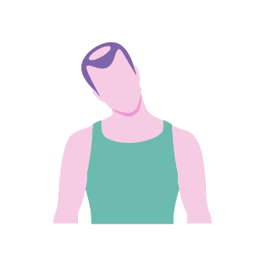
Dream – Lean head slowly
to the right and slowly to
the left twice.

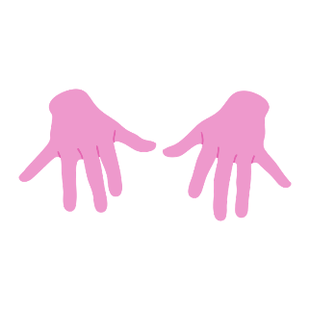
Afraid – Stretch arms out
in front and shake.
Twiddle fingers.

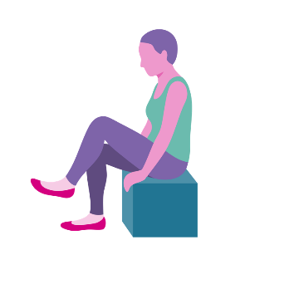
The Roman emperor told everyone to go to their home town. It was a long journey to Bethlehem. (Discuss long journeys that people have been on. Where did they go? How would/did they travel? Who drove a car? Has anyone had to give up driving and how did that feel?) There were many other people and all the inns were full. (Encourage people to knock on the door and reply ‘no room’. Ask if any residents were in the Nativity Play at school). Mary and Joseph stayed in a stable. Mary gave birth to Jesus and laid him in a manger.
Go – Leg lifts. Remind residents to uncross their legs. Raise one leg at a time and hold for 2 seconds. Relax and then raise the next leg and repeat twice. For those with greater mobility we usually count
out 10 lifts.

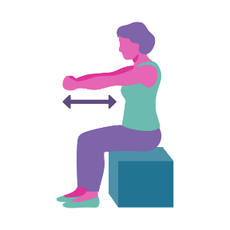
Journey – Imagine holding onto a stirrup and riding a donkey. Move arms towards chest and then straight out
in front. Repeat 5 times.

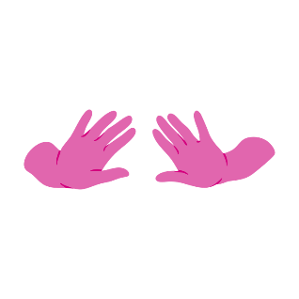
People – Push our way through the crowd of people. Hands start in front of chest and push outwards and slowly move arms out as if doing a breast stroke. Repeat 3 times.

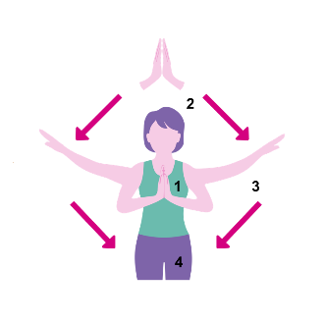
Birth – Prayer position – breathe in and raise arms above head and breathe out as you lower arms to the side. Do this twice.

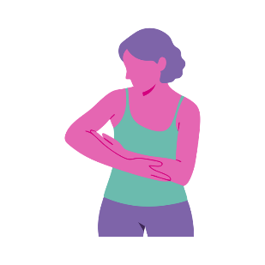
Rock the baby – Gentle shoulder movement –
5 swings.

Prayers
- There are times in life when those close to us have disappointed us or upset us. Help us to trust in you Lord, as Joseph did. Help us not to be afraid.

- At this time of year people are making plans to spend Christmas together. The airports, trains and motorways will all be busy. We pray for all our families and friends who might be making journeys this December.

- The prayer of St Christopher and St. Christopher medals are very common. Saint Christopher Prayer "Motorist's Prayer:" Grant me, O Lord, a steady hand and watchful eye, that no one shall be hurt as I pass by. Thou gavest life, I pray no act of mine may take away or mar that gift of Thine. Shelter those, dear Lord, who bear my company from the evils of fire and all calamity. Teach me to use my car for others need; Nor miss through love of undue speed. The beauty of the world; that thus I may with joy and courtesy go on my way. St. Christopher, holy patron of travellers, protect me, and lead me safely to my destiny.)

- Saint Christopher's Protection Prayer Dear Saint Christopher, protect me today in all my travels along the road's way. Give your warning sign if danger is near so that I may stop while the path is clear. Be at my window and direct me through when the vision blurs From out of the blue. Carry me safely to my destined place, like you carried Christ in your close embrace. Amen.)

- There was no room at the inn for Mary and Joseph. Help us to be welcoming like the innkeeper and give what we can give: a smile, a reassuring handshake or a little nod.

Quiet reflection/meditation: Silent Night

Suggested Carols: O Little town of Bethlehem, Silent Night, Once in Royal David’s city, Away in a Manger.

* Example of action that you can use to talk about carpentry skills.

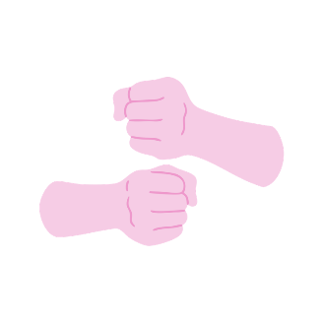
Example of action for hammering nails. Residents will often remember the rhyme
One potato, two potatoes, three potatoes, four.
Five potatoes, six potatoes, seven potatoes, more.

Session Three for Advent Reflection
Shepherds in the field
Luke 2:7-21

Jesus had been born in Bethlehem (See if anyone could remember where Jesus was born. Ask residents where they were born). Some shepherds were in the fields keeping watch over their sheep. (Are there any farmers present? What animals have they looked after) Suddenly, an angel surrounded by dazzling light appeared. The shepherds were scared. (What do we do when we are scared? Flight or fight?) ‘Do not be afraid, I bring good news. God’s son has been born tonight’.

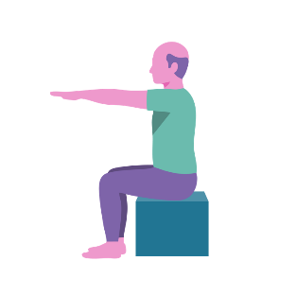
Watch over – Hold arms straight out in front and hold for 5 seconds and relax and repeat.

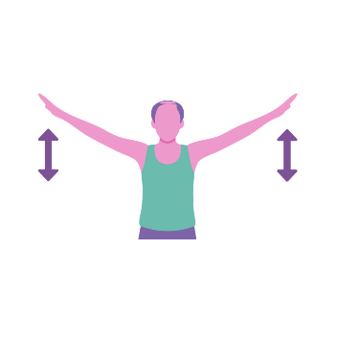
Angel wings – Slow movements up and down
5 times.

Scared – Stretch arms
out in front and shake. Twiddle fingers.

A great company of angels appeared in the sky singing (Ask if any residents were members of a choir) ‘Glory to God in the highest heaven and on earth peace to people of good will’.
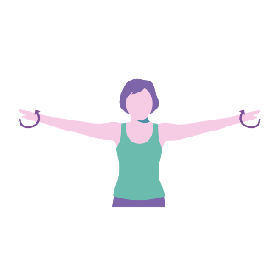
Angel wings – Arms straight out to the side and make small circular rotations clockwise for 5 turns and anticlockwise for 5 turns.

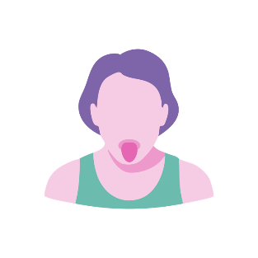
Singing – Lion face – Stretch the face by opening eyes wide and sticking tongue out. Try singing ‘la’ going up and down an octave.

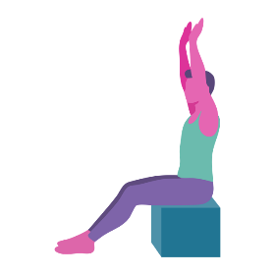
Highest – Lift arms above head and hold. (Remind residents only to do moves that are comfortable – arms can be held in lower position in front of chest).

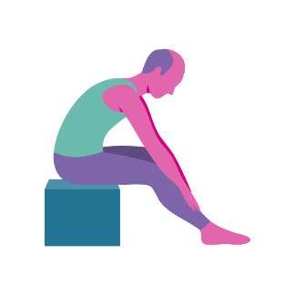
Earth – Hands on knees and move hands slowly down legs as far as is comfortable. Slowly move back to seated position.

When the angels had left, the shepherds said ‘Come on, let’s go and find this special baby’. They found baby Jesus lying in a manger. The shepherds told Mary and Joseph all about the message the angels had given. The shepherds returned to their flocks glorifying and praising God. (Discuss news of a baby’s birth and how we share other good news stories with family and neighbours).
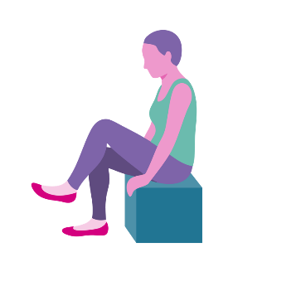
Go – Leg lifts. Remind residents to uncross their legs. Raise one leg at a time and hold for 2 seconds. Relax and then raise the next leg and repeat twice. For those with greater mobility we usually count
out 10 lifts.

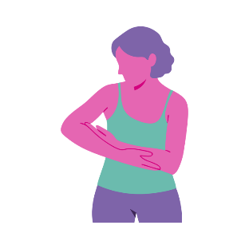
Rock the baby – Gentle shoulder movement.
5 swings.

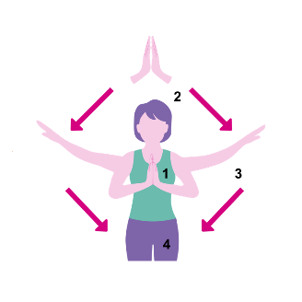
Message – prayer position – Breathe in and raise arms above head and breathe out as you lower arms to the side. Do this twice.

Prayers:
- Thank you Lord for the children we have shepherded. Help us to continue to be good shepherds to our family members.

- Be with us Lord when we are afraid. Help us to go on with courage to come ever closer to you.

- Getting older brings different challenges to us all. Help us to be accepting of each other and continue to praise you for all the blessings we have received in our life time.

- Help us to share in the good news of others when we feel despondent and depressed.

Suggested Carols: The first noel, While shepherds watch their flocks by night, O come all ye faithful.

Fourth Session for Advent Reflection
The Wise Men
Matthew 2:1-12

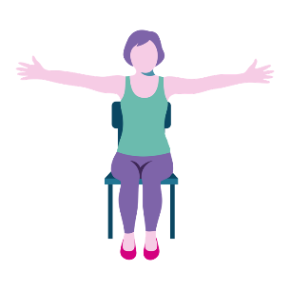
Jesus was born in Bethlehem (Ask if anyone can tell you where Jesus was born. Use prompts like the start of ‘O little town of ….’). Astrologers from the east arrived in the big city of Jerusalem after a long journey. The three astrologers told King Herod that they were looking up at the stars. (Discuss: Does anyone like reading their horoscope. Is it just fun or is there any truth in it?). They explained that the big star was telling them a King had been born. King Herod was not pleased to hear about a new King.
Big – Arms stretched out
to the side and hold for
5 seconds.

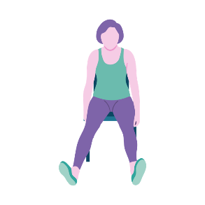
Long journey – Lift both legs up and like scissors move feet together and apart. Repeat 3 times and relax.

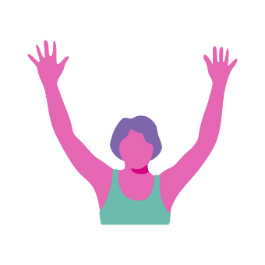
Look up & stars – Arms above head and twiddle fingers. Slowly lower head
to look up at the stars.

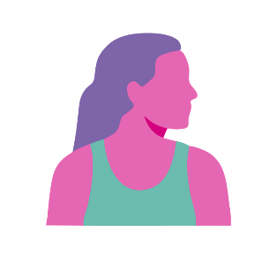
Not pleased – Move head slowly from left to right twice.

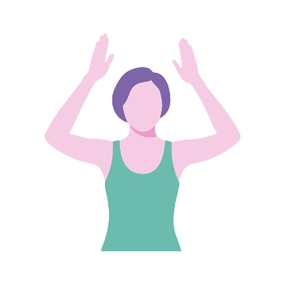
King – Imagine holding a crown and lifting it up above head. Hold and lower crown back onto head. Repeat twice. (For those who cannot lift their arms above head simplify movement by holding crown in front of them).

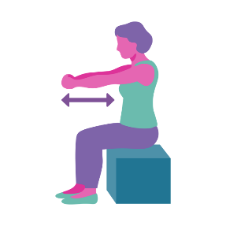
The wise men continued their journey to Bethlehem (How did the wise men travel to Bethlehem? The image we have is of them travelling by camel. Discuss how we might make a long journey, what forms of transport would we use? How far have people travelled? Has anyone ridden a camel or a horse?). When they entered the house, the wise men bowed to the ground in homage. They brought gifts of (ask residents what the wise men brought. Discuss what gifts we would give for a baby) Gold, Frankincense and Myrrh (could give people a little hand cream to rub into their hands). In a dream the wise men were warned not to go back to King Herod so they returned home another way.
Journey – Imagine holding onto a stirrup and riding a camel. Move arms towards chest and then straight out in front. Repeat 5 times.

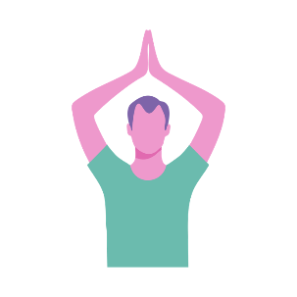
House – Position hands above head and from the waist make a twist to the right and then to the left. Those who cannot lift arms up can put their hands in prayer position and twist from there.

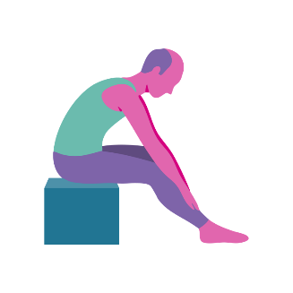
Bowed – Hands on knees and move hands slowly down legs as far as is comfortable. Slowly move back to seated position.

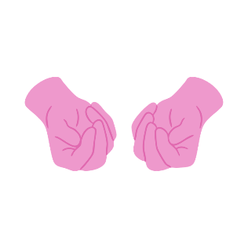
Gold – Finger movements. Touch baby finger with thumb and move thumb to
all other fingers in turn for coordination.

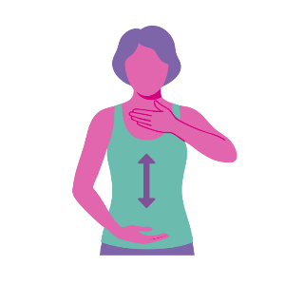
Frankincense – Move one hand towards nose as if to smell something and then as you move that hand down, raise the other hand towards the nose.

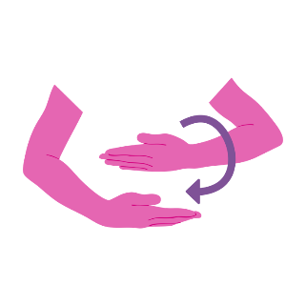
Myrrh – Place one hand above another and rotate one around another as if folding shroud.

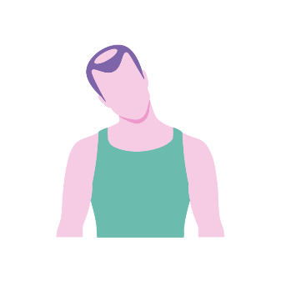

Dream – Lean head slowly
to the right and slowly to the left twice.

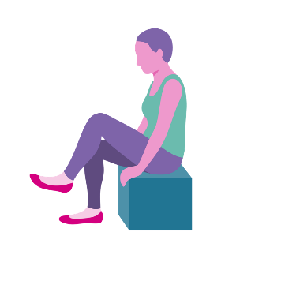
Return home – Leg lifts. Remind residents to uncross their legs. Raise one leg at a time and hold for 2 seconds. Relax and then raise the next leg and repeat twice. For those with greater mobility we usually count
out 10 lifts.

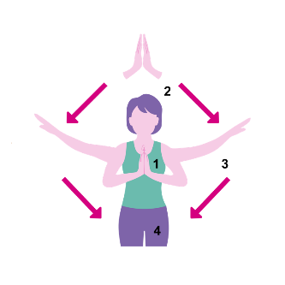

Reflection – prayer position – Breathe in and raise arms above head and breathe out as you lower arms to the side. Do this twice.

Prayers

- Lord, help us to trust in your divine will for our lives, just as the wise men followed you.

- We thank you for all you have created and the beauty of the galaxy of stars.

- We pray for all those journeying this December to be with family and friends.

Suggested Carol: We three Kings.

Carol Service
Opening Carol: O come o come Emmanuel

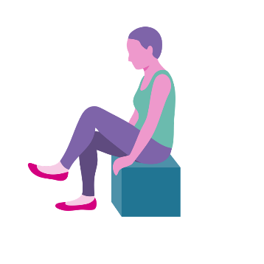
Mary and Joseph were on a journey to Bethlehem (Residents can shout out the answer – prompt them using ‘O little town of …..’). When they arrived in Bethlehem the inns were full, there was ‘no room’ (Knock and encourage residents to respond with ‘No room’ as the inn keeper would have said. In Nativity plays this was done three times). Mary and Joseph stayed in a stable (ask residents what animals there might be in a stable – use a nativity scene to start building up the picture – take round some soft toy animals for people to hold on their lap). There Mary gave birth to baby Jesus and laid him in a manger. (Place baby Jesus in the nativity scene).
Journey – Leg lifts. Remind residents to uncross their legs. Raise one leg at a time and hold for 2 seconds. Relax and then raise the next leg and repeat twice. For those with greater mobility we usually count
out 10 lifts.

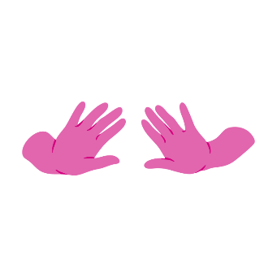
People – Push our way through the crowd of people. Hands start in front of chest and push outwards and slowly move arms out as if doing a breast stroke. Repeat 3 times.

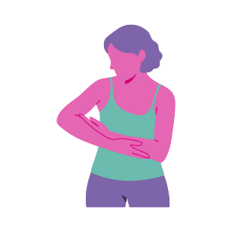
Rock the baby – Gentle shoulder movement.
5 swings.

(Discuss: What makes this story so powerful? It has been retold for over 2000 years. It has been translated into over 1500 languages. Why do we love this story so much? Is it because Mary was an ‘ordinary girl’ and Joseph was an ‘ordinary man’. They were humble and poor and yet chosen by God to raise the Messiah. Many of us will remember our own humble beginnings and yet like Mary and Joseph we did our best at that time, in our relationships, in bringing up children, in work and in making decisions in our lives.)

Sing: ‘Away in a Manger’

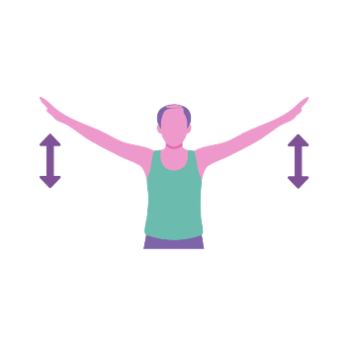
Shepherds were in the fields minding their sheep (Anyone with a soft toy sheep lift them up for others to see) when they were visited by angels who told them where to find the Messiah. The glory of the Lord shone around them.
Angel wings – Slow movements up and down
5 times.

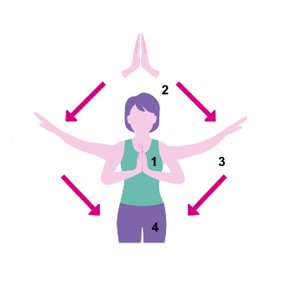
Glory – prayer position – Breathe in and raise arms above head and breathe out as you lower arms to the side. Do this twice.

(We all have a responsibility to be good shepherds, to be a good example to others. We are also God’s sheep and we trust that in following Him we will find true happiness and salvation).

Sing: ‘While shepherds watch their flocks by night’

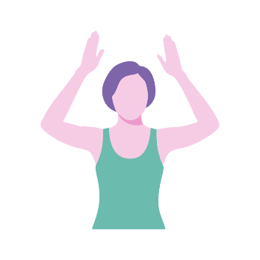
Three wise men came in search of the infant King (Now place the three wise men in the nativity scene). They rode across the desert and brought gifts of gold, frankincense and myrrh. (If possible have some props or something for residents to smell). They paid him homage.
King – Imagine holding a crown and lifting it up above head. Hold and lower crown back onto head. Repeat twice. (For those who cannot lift their arms above head simplify movement by holding crown in front of them).

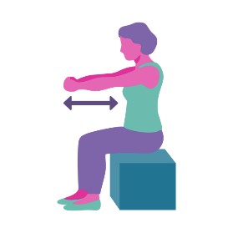
Rode – Imagine holding onto a stirrup and riding a camel. Move arms towards chest and then straight out in front. Repeat 5 times.

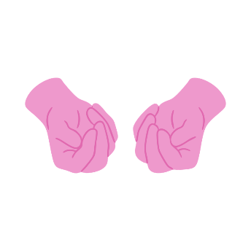
Gold – Finger movements. Touch baby finger with thumb and move thumb to
all other fingers in turn for coordination.

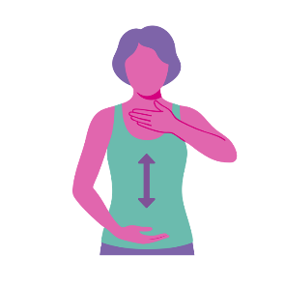
Frankincense – Move one hand towards nose as if to smell something and then as you move that hand down, raise the other hand towards the nose.

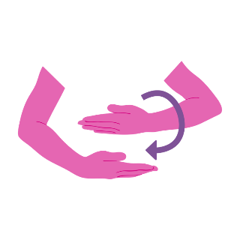
Myrrh – Place one hand above another and rotate one around another as if folding shroud.

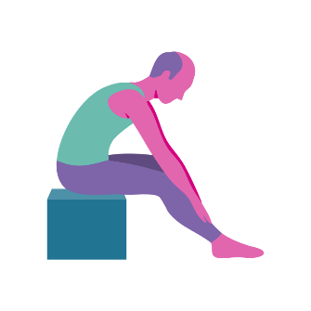
Homage – Hands on knees and move hands slowly down legs as far as is comfortable. Slowly move back to seated position.

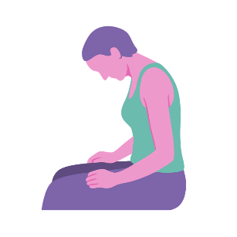
Relaxation – You can start by doing some neck exercises and ending with the bow forward as you use the time at the end for prayer or meditation.

(Gift giving is synonymous with Christmas. What gifts do we usually give to men? What do we usually give to women? It’s the thought that counts. Better to give than to receive – do people agree? Today we have come together to celebrate and share in this Carol Service together. Our presence and our participation is the greatest gift you could have offered today. Thank you)

Sing: ‘We three kings’

Matthew 1:18 – 2:12 & Luke: 1:26-2:20

Prayers

- We pray for our residents, staff and visitors to our Homes and Schemes this Christmas

- Thank you for all the joy and special moments we have shared this year.

- We ask you to bless each of us and help us to accept your unconditional love.

