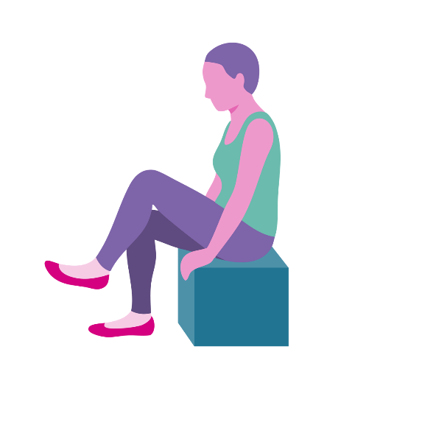

Multi-Generational Biblical Yoga – Lent and Easter Resource

Written and developed by Yvonne Myers
- Chaplain at MHA Amathea.
Foreword
Biblical yoga is designed to help people living with dementia to connect to scripture in the Bible and enable discussion. Biblical Yoga breaks down a passage from the Bible by involving participants with low intensity and low impact movements. The passage is broken down to enable participants to reflect on meaning and give opportunity to express their beliefs and views, while also giving opportunities for reminiscence. Those with dementia need to be able to hear the message in that moment and this is done through interaction with the story. Bible stories can be difficult for children to understand. Breaking the reading down and getting them to be part of the story will help to make it meaningful. Biblical Yoga will give them an opportunity to ask questions and reflect on the meaning of the passage.
Movement and exercise are an important part of our wellbeing. Breathing exercises increase oxygen levels in the body and have a calming affect. The movements and smiles help to release the happy hormone endorphin; improving the sense of wellbeing. Each session has a variety of exercises for lower and upper body, using coordination and breathing exercises. The regular exercise helps older participants to stay mobile, more alert and reduces the risk of falls. Biblical Yoga is low impact and low intensity designed for older and frailer adults and for those with disabilities.

Testimonials
“May I commend Biblical Yoga to you. I had the wonderful privilege of attending a Biblical Yoga act of worship at Amathea MHA in Workington in the Cumbria District where I serve as District Chair. The act of worship was prepared and led by the Chaplain Yvonne Myers. I was transfixed by what happened. The room was full of people who were at various stages of dementia and Yvonne introduced a familiar biblical story which took 50 minutes to complete in which all those people present engaged in what for me was an unexpected way. People who I had not seen speak or interact were all of a sudden immersed in the story, mentally, physically and spiritually. They came to life and God was very present in that room. I have continued ever since to tell the story”.
Rev. Richard J Teal (Chair of the District of Cumbria)
“I have both participated in Biblical Yoga and spoken with many people who have experienced sessions in a range of settings. Without exception it has been spoken about in the most glowing terms, enabling people to enter into worship and Bible study in a way which is both immersive and rewarding. It has a particular benefit in stimulating the engagement of people living with dementia. As many of us realise from personal experience, anything which enhances the lives of people living with the impact of dementia is immensely valuable”.
Chris Swift (Director of Spirituality for MHA)

“What a wonderful idea. A simple concept (although I know a lot of thought goes into the preparation). Many people living with dementia are at an age when as children they went to Sunday school. I have very happy memories of Sunday school and this took me back to those days. Not only does it rediscover memories of the biblical stories we learned as children, but the movements help engage both our brains and our bodies and trigger those spiritual feelings that bring contentment and peace. So, an ideal activity for people living with dementia. What could be better? Something simple that creates many moments of joy. Well done Yvonne, I love it”.
Hilary Doxford (Ambassador and Research Network volunteer for Alzheimer’s Society), March 2019

Contents
Why Biblical Yoga 6
Before you begin 7
Leading a Session 9
Lent and Easter Biblical Yoga Sessions 12
Ash Wednesday 13
Washing of Feet 24
Last Supper 31
Palm Sunday 38
Good Friday and Easter 47
About the Author 56

Why Biblical Yoga?
Biblical Yoga is based on the bible. Yoga is a spiritual exercise discipline unlike movement or exercises. Yoga is about slow movements that are low intensity and low impact. Yoga stretches muscles and builds core muscle strength and good posture. Yoga is about mindfulness and looking to the spiritual self. Yoga also incorporates breathing techniques too. The word Yoga best suites this type of activity. However, if the title does not suit the target audience, then a more suitable title can be chosen. The important thing is that biblical Yoga improves body, mind and spirit.

Biblical Yoga was primarily designed to help engage people living with dementia with the Bible and make it meaningful although it has started to be used with young children and may prove helpful to those with a learning difficulty and those on the autistic spectrum. It has long been established that people have different learning styles, auditory, kinaesthetic and visual. Biblical Yoga is successful because it incorporates all three learning styles, auditory through hearing the Bible passage being read, the movements explained and being given an opportunity to answer questions and share experiences. Visual is that the movements are demonstrated and most likely you will be in a church environment or will have a focus table set up with visual clues that set the scene. Kinaesthetic, because the leader and the participants are engaged in physical movement. The movements help people to feel part of the passage in the Bible.
Before you begin
This is a health and safety checklist of things you may need to think about before leading a session. Always seek advice if unsure.
-
You may wish to complete a Risk Assessment.
-
Make everyone aware that if they have any medical issues that make them unsure of whether they should participate then they are welcome to observe.
-
Remind people that if they are in any pain then they should only do movements that are comfortable. Should any of the movements cause pain, discomfort or make one feel faint they should stop immediately and inform someone who can get medical attention.
-
Visually check the room for hazards. There should be ample space to the side of each person but not so far away that people feel disconnected from each other.

Try to use a room that is light and where a window can be opened in warm weather. Consider closing the doors if there is likely to be substantial noise distraction.
-
If in a Care Home setting, a carer must be present during the session. You should always ask the Senior Carer if there are any changes to residents’ health that you need to be aware of before the start of each session.
-
Before beginning, explain that the session involves doing some movements and that participants should only do movements that feel comfortable. It is good practice to remind people of this throughout the session, especially when moves involve arms or shoulders.

The issue of consent is simple. If people are taking part of their own will and are not being forced to do anything then they are consenting. You may wish to create a consent form explaining the above and ask them to sign. In Care Homes residents or their next of kin sign a consent form for them to take part in Activities. If visiting a Care Home or similar establishment you may wish to ask the Care Home Manager about this to clarify.

Leading a Session
If using within a service you may wish to use a familiar order of service or a concise order of service depending on the community you are serving. When working ecumenically remind the group that all contributions are welcome and that this is a place where we value and accept different points of view.
At the beginning of a session explain that you will be encouraging people to copy your movements. Make it clear that anyone who does not wish to or feels they should not engage because of medical concerns, is not obliged to take part in the movements. Advise that everyone is welcome to take part at a level that is comfortable to them. No one should do any movements that they feel unable to do and if they feel any pain or feel dizzy they should stop immediately and tell someone. If someone in the group is unsure whether they should take part they should be advised to ask their GP for guidance.
Demonstrate to participants how to do each movement. This can be done by the reader or by another person demonstrating the actions. In a larger church you may want two people to model the activities as the passage is read. This is also helpful as one person can go and assist someone with sight problems more closely while the other person continues to model the activity for the congregation or group. Show people how they can do an easier version of the movement and correct bad posture. Acknowledge participation as recognising achievement is vital in motivating and encouraging engagement.
Praise and encourage people as you walk around and engage with participants on a one to one, showing them how to do the moves and making eye contact. Simply holding out your hands will in most cases make the person you have eye contact with, hold out their hands towards you. You may swing your body a little and this will help them to react by swinging their arms. At no point have you pulled them or moved them but you are moving with them. You may also need to support participants one-to-one by indicating to them that you would like them to uncross their legs for a particular exercise. Remember that you may need to repeat instructions a few times as reaction and response times decrease with age. Makaton is a helpful communication tool.
Adapt the number of movements to suit the ability of the group and individuals. Do not worry if participants do not engage with all the movements. They are free to choose which movements they would like to do and at liberty just to watch. You may like to explain why a movement is beneficial (muscle strength, joint movement, ease neck or back pain, coordination). The more Biblical Yoga is used, the more familiar the movements will become to you and the participants and the more relaxed you will be about the delivery.

It is recommended that the passage is read again alongside the movements. Participants usually engage with the movements much easier the second time round and it helps to bring the whole passage together for final thoughts.
End the session with a time of reflection, meditation or prayer. This gives participants an opportunity to ‘cool down’ after the activity. Use counting for breathing techniques and imagery from the bible reading as part of the meditation. Refreshments may be offered before further discussion. You may like to use a whiteboard to write down some of the key thoughts and reflections from the passage.

Lent and Easter Biblical Yoga Sessions
The Good Friday Service will showcase some of the movements you’ve been working on. Biblical Yoga can be used as part of a Worship Service but it is not necessary if working with a non-faith school. The passage is read slowly and there are opportunities as you go along for discussion, reminiscence and spiritual debate. Biblical Yoga can be enjoyed by people of Christian faith and none when done as a stand alone session. I have included suggested prayers, hymns and points for discussion. People living with dementia benefit from prayers that are kept short and meaningful. Depth of discussion will depend on the participants in the session. The aim is for participants to communicate with each other about their beliefs, values and morals.
Below is a suggestion of how to use the sessions to fit into the school timetable. You may be able to offer to do one of these sessions as an Assembly or offer to run an After School Club.
Time table of sessions
 | School Term A
Ash Wednesday | 26th March
Washing of Feet | 4th March
Last Supper | 11th March
Palm Sunday | 18th March
Good Friday and Easter | 25th March
Ash Wednesday
We are starting the season of Lent. What do people do during Lent? What things have you given up before or plan to give up this time? When Jesus grew up he left home and spent 40 days and 40 nights in the desert praying. He gave up food and went to a quiet place so that he could be closer to God. Some people use Lent as a way of making a new resolution, a promise to do something differently. This Lent we could make an effort to improve our relationships by spending more time with people we care about or spending time with God in prayer. Today Jesus gives us some advice about how to pray.
Hymns suggestions
Make me a channel of your peace
Our Father who in heaven art
Father in heaven
Matthew 6:1-20

Jesus said “Long prayers and fancy words are not important when you pray. Pray privately in your room.
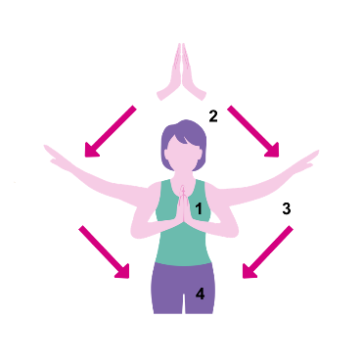
Where can you pray?
What prayers do you remember?
What would you pray about? What is important to you?
Do you sometimes find it difficult to know what to say? God the Father knows what you need before you ask him”.

Place hands together in a praying position.
Raise your praying hands together as if they are going up to heaven as you breathe in. Hold and breathe out as you lower your arms to the side and relax. Repeat twice.

Jesus said “pray like this: Our Father, who art in heaven,
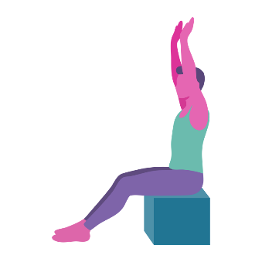
What is heaven? Where is it?
Raise both arms above head. Hold for 3 seconds and relax.

Hallowed be thy name,
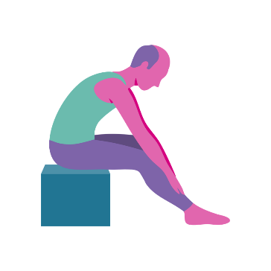
Holy. What do we mean by holy?
Place hands on your knees and slowly move hands down legs towards the feet to a point that is comfortable. Hold and slowly move back to seated position.

Thy kingdom come,

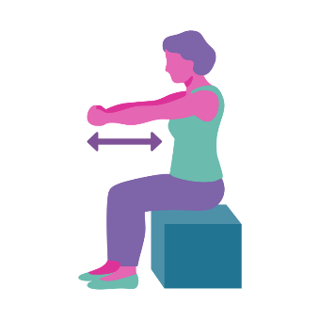
What kingdom is Jesus talking about?
Place arms out directly
in front and bring hands
in towards the heart
and relax.

thy will be done,

How do we know when we’ve done the right thing?

Place thumbs in an
upright position.

on earth

The earth is very big. Where on this earth have you been? How far have you travelled?
God’s will on earth. What would that look like? Peace, love, care?
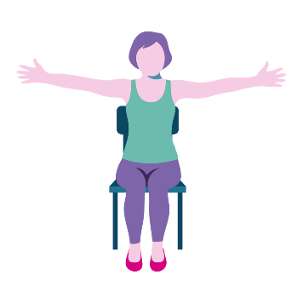
Place arms out to the side as if wrapping your arms around the world. Hold for 5 seconds and relax.

as it is in heaven.
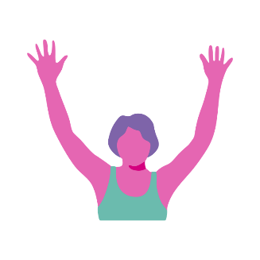
How can we create heaven on earth?
Raise arms above
head and reach up
to heaven. Hold for 3 seconds and relax.

Give us this day our daily bread

What things do we need each day?
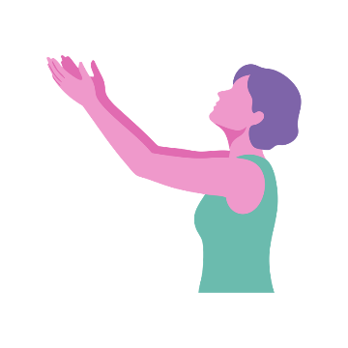
Give us everything we need today God.
Hold hands out in
front and hold for
the count of 5.

and forgive us our trespasses,

Explain the word trespass to younger children.
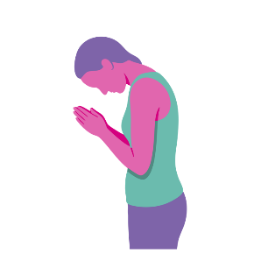
Forgive us when we have done wrong, through negligence, through thought or deliberate fault.
Put hands in praying position and bow head forward.

as we forgive those who trespass against us.

Is it important to forgive people?
How do we forgive someone?
Shake hands, hug.
What makes it hard to forgive? Sometimes we need to forgive to move forward.
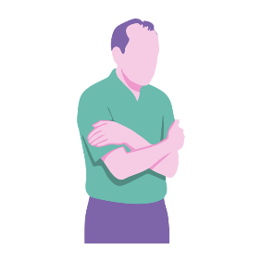
Place hands on opposite shoulders and give yourself a hug. When we forgive someone, we usually give them a hug.

Lead us not into temptation but deliver us from evil.”

What sort of things are ‘tempting’.
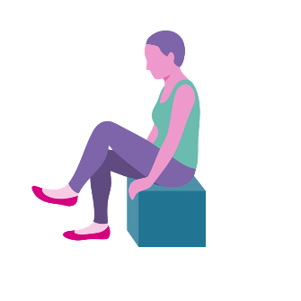
What is sin?
Committing sin can harm us and other people.
Raise one leg up, hold and relax and repeat with the other leg. Those more able can do marching on the spot in sets of 10.

Jesus said ‘When you are fasting, do not be miserable.

What makes you feel miserable?
Research shows that if you look miserable you will feel miserable.
What is fasting?

Research suggests that if you smile you will feel happier, more positive and feel less pain.
Put on a miserable face and reflect on how it makes you feel.

No one should recognise that you are fasting, put scent on and present yourself well’.

Have a selection of perfumes that people
can smell.
Do you like going to the hairdressers? How often do you go?
Looking our best makes us feel better and more positive. Do you agree?

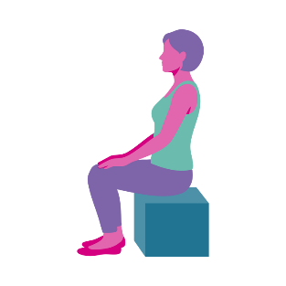
Get into a good
seated position.

Summary
Fasting is a little like going through a difficult time. Failing memory and ill health are some difficulties we suffer as we get older. However difficult things are, we can make the effort to do our best today. What makes us feel better (positive wellbeing: social interaction, exercise, enjoying food, engaging in activities). How did you get through difficult times in the past? Best foot forward, keep your chin up.
Research shows that smiling even when we are sad can reduce pain and make us happier. Song ‘smile though your heart is aching’ Music written by Charles Chaplin in 1936 for the film ‘Modern Times’. John Turner and Geoffrey Parsons added lyrics and the song was sung by Nat King Cole in 1954.

Prayers
When words fail us, let us have faith that you understand our every need.
Lord, help us to focus on what we can do.
Dear Lord, remind us to smile through any difficulties we have.
Activities
Opportunity to talk about ethical principles and how we can often ‘trespass’ because we have not thought about the impact we are having. Discuss fair-trade, discuss where much of our clothing is made and the environmental and social impact that has, discuss our waste and importance of recycling
Have a taste session of various fair-trade products
Watch Charley Chaplin ‘Modern Times’ and discuss film history
Bring in some perfumes for people to smell and discuss what memories they associate with different smells
Bread making

Smile
Smile though your heart is aching
Smile even though it's breaking
When there are clouds in the sky, you'll get by
If you smile through your fear and sorrow
Smile and maybe tomorrow
You'll see the sun come shining through for you
Light up your face with gladness
Hide every trace of sadness
Although a tear may be ever so near
That's the time you must keep on trying
Smile, what's the use of crying?
You'll find that life is still worthwhile
If you just smile
That's the time you must keep on trying
Smile, what's the use of crying?
You'll find that life is still worthwhile
If you just smile

Washing of Feet
Who washes your feet? We usually wash our own feet. In Jesus time when most people wore sandals or walked bare foot, feet would be dusty and dirty. At the time when Jesus was alive, washing of feet was a task that only household slaves would perform. Today we are going to hear about Jesus washing his friends’ feet and reflect on why he did this.
Hymn suggestions
Richer than Gold is the love of my Lord
The gift of love
God moves in a mysterious way
John 13:1-15 & Luke 22:24-27
It was the day before Passover
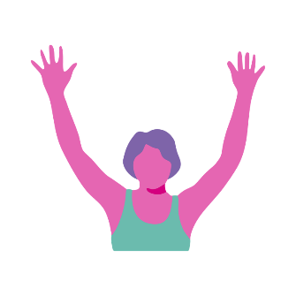
Passover is a Jewish festival where they commemorate the time when they were delivered from slavery in Egypt.

Raise arms in air and wave from side to side like a wind passing over your head.

They were eating supper when Jesus overheard some of his disciples discussing who was the best.
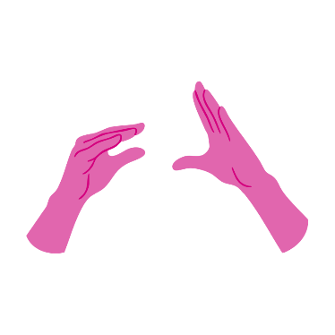
What do you like discussing at the dinner table?
We all want to be important and God wants us to respect ourselves but he does not want us to hurt other people.
‘Happy talk’ open and close hands as if they were both talking.

Jesus told them “A leader must serve people”

Can you think of people who are leaders? How do they serve?
If a leader doesn’t serve they don’t get our respect and we don’t like them.
What happens to a Prime Minister who doesn’t serve us well?

When we are of service to others we are looking out for people so we are going to tilt our head to the right and then the left, forward and back

Examples of lower body movements
Jesus got up and wrapped a towel around his waist
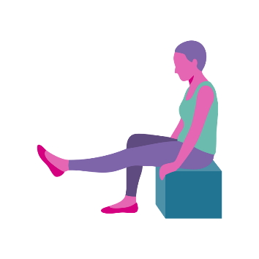
Where was he going with this towel? What do you use a towel for?
Jesus friends didn’t know what he was going to do either!
Raise one leg straight out in front and hold and relax. Repeat with the other leg.
For those more able ask them to repeat this a few times.

Jesus poured water into a bowl
How did they do this?
Were there any taps in Jesus time?
Where did they get water from?
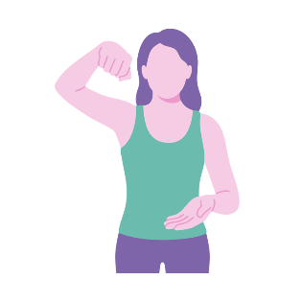
Imagine holding a jug
and pouring water into
a bowl.

Jesus kneeled down
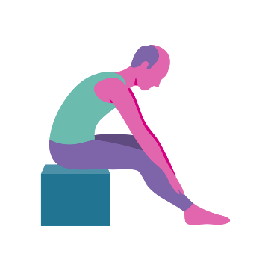
When do we kneel? Jobs around the house?
Why do we kneel in church?
Place hands on your
knees and slowly move down your legs towards your feet.
This stretches the
lower back and legs.
The straighter the legs,
the better the stretch.

Simon Peter exclaimed “You’re not going to wash my feet!”

Does anyone here have tickly feet? How would you feel if I came to wash your feet?
What do feet smell like? Feet can be smelly and dirty. Simon Peter was embarrassed; he did not want his friend Jesus to wash his feet
Raise one foot at a time and wriggle the foot and ankle. Relax and raise the other foot.

Jesus explained that he was washing their feet to show them how much he loved them.

What sort of things do parents do to show you how much they love you? Washing your clothes, changing nappies, cleaning your room.
Make a heart shape with your hands.

Jesus began washing the disciples’ feet
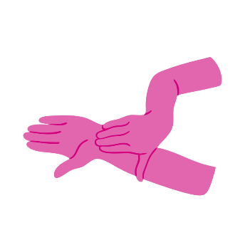
Because some of us do have tickly feet and because of hygiene we are not going to wash each others’ feet. However we are going to take a wet wipe and wipe each others’ hands.
Take a little hand cream and give each other a hand massage. Do this carefully and gently to show how much we care for each other.
Take some hand cream and massage into
the hand.

Summary
Jesus explained that no one is more important than anyone else. “Be of service and help each other” and people will know you are my friends.
Jesus taught us to lead by example. Jesus wants us to be or service to others. Simon Peter did not understand the significance of Jesus washing his feet. Simon Peter found it difficult to accept Jesus washing his feet. Do we sometimes find it difficult to accept help and assistance? It can feel embarrassing to need help. We want to do things on our own. There are many ways you have served others in your lifetime, at home, work and socially. Let us try to accept service from others that is done out of love, just as the disciples accepted service from Jesus.
Prayers
Dear Lord, help us to be of service to you by offering our love to others.
As we get older we need more help. Lord, help us to accept others’ service to us.
We pray that we can accept love from others and love others in return.

Activities
Look at reflexology of the hand – another good excuse for a hand massage.
Craft activity making paper hearts with a simple message or a person’s name to hang on a twig tree
Make chocolates and give to someone you love
Nail painting
Label parts of the body
Research Jewish Passover
Look at people who have influenced through leadership

The Last Supper
There is nothing like sharing a meal with family and friends. As we approach Easter the adverts on television are advertising families getting together for Easter Sunday dinner. In Jesus time people were preparing to eat the Passover Meal and as with all good social mealtimes there are some interesting conversations.
Hymn suggestions
For the bread which you have broken
This is my body
Let us break bread together
Matthew 26:17-28 & Mark 14:12-24
Jesus and his disciples went to a house in the city
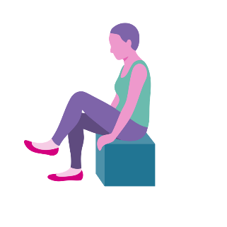
What type of house do you live in/have lived in? Have there been any parties or family meals there?
Raise one leg up, hold
and relax and repeat
with the other leg. Those more able to do marching on the spot in sets of 10.

They were preparing to eat Passover
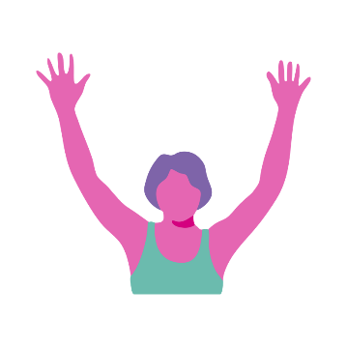
Talk about where Passover came from and why the Jews celebrate this.
Christians do not celebrate Passover in this way but can you think of other celebrations where we sit and eat together?
Raise arms above head and wave from side to side as if wind was blowing above your head.

They were sat down eating Passover

Passover has been celebrated by the Jews since 1300BC
The seder meal: unleavened bread (matzo), lamb, greenery, salt water, charoset (a paste made of apples, nuts, cinnamon and wine).
What food is traditional for us at Easter?
Imagine chewing something and move mouth accordingly.

Jesus said “I tell you solemnly, one of you is about to betray me.”
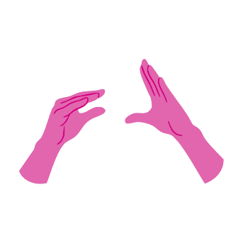
Betray means to harm or be disloyal. Have you had the experience when a friend has shared some of your confidential/secret information with someone else?
‘Happy talk’ open and close hands as if they
were both talking.

The disciples were greatly distressed and turned to one another to discuss it.

What do you talk about with your friends?
Look to the right and
then to the left.
Repeat movement.

They were saying “Not I Lord, surely?”
Have you ever betrayed anyone?
Is it sometimes difficult to know whether to tell somebody about something – safeguarding, safety at work, bullying.
Sometimes people ask you not to tell anyone but if you think you need to it is best to be honest and say ‘I feel I need to tell a carer/teacher/parent about this.
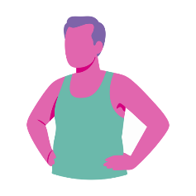
Hands on hips and twist a little from side to side if comfortable to do so.

As they were eating, Jesus took some bread. He said the blessing and broke it.
Christians often say a prayer before mealtimes to thank God for the food.
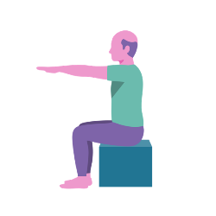
How would you say thank you for your dinner?
Hold arms out directly
in front of you and hold and relax.

He gave it to his disciples saying “Take it and eat; this is my body”.
How was Jesus going to die?
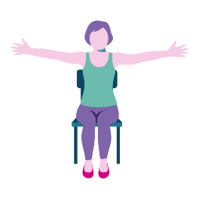
Receiving communion is an important part of Christian life. Some Christians believe that the bread changes into the body of Christ and others believe that it represents Christ. What does communion mean to you? Do you feel nourished by it?
Hold arms out to the side, hold and relax.

Then Jesus took the cup and said “Drink, for this is my blood, the blood of the covenant, which is poured out for many for the forgiveness of sins”.
What is a covenant?
What sort of promise was Jesus referring to?
When Jesus died he made God more accessible
to all of us. God is for everyone and not a select group.

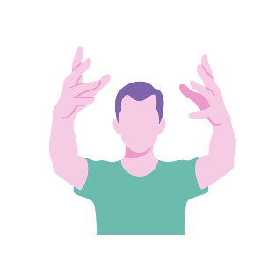
Lift arms out in front as
if raising the cup to show everyone.

Summary
Christians come together once a week on a Sunday by going to church as a community. The bread and wine we receive is called communion because it is something the community is sharing in common. Gathering together as a community is valuable for bringing people together. The Greek word ‘eucharistesas’ means to give thanks. We give thanks through singing hymns, receive Jesus through hearing the scriptures, receive communion and pray for others.
Prayers
We give thanks for all the family meals we have been part of.
Help us to know when we need to talk to someone.
We pray that we receive you today in listening to your word.

Activities
Have some pictures of family meals
Look at recipes and discuss order of tasks in the kitchen. For example: Roast potatoes – peel, cut, oil, bake. Use pictures of stages.
Make a cake or cupcakes.
Bake some bread or have bread taster session
Discuss safeguarding and explain process of concern.
Watch some BBC Class clips about Sacraments – Holy Communion

Palm Sunday
So far we have talked about making time for reflection and prayer. We have talked about serving other people through love and about the importance of sharing a meal together. For people who have given something up for Lent, reaching Palm Sunday is a sign that the fasting is nearing an end. It is the start of Holy Week. The people of Jerusalem were really pleased that Jesus had come. Today we will hear how excited they were and how they welcomed him.
Hymns suggestions
Ride on ride on in majesty
All glory laud and honour
All people that on earth do dwell
Matthew 21:1-11, Mark 11:1-10, John 12:12-16, Luke 19:28-38

Jesus and his disciples were walking towards Jerusalem.
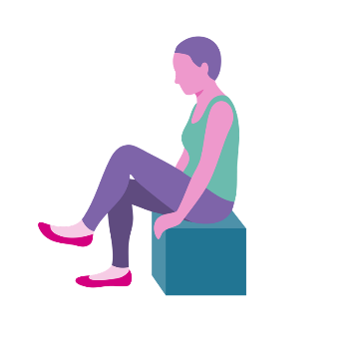
Do you do much walking?
Raise one leg up, hold and relax. Then raise the other leg, hold and relax.
Repeat as many times as is comfortable.
Those who are more able can march on the spot in sets of 10.

Jerusalem was a big city.
What’s the biggest city you’ve ever been to?
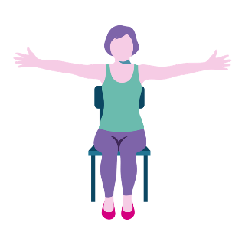
Did you see any famous buildings?
Stretch arms out to either side so show how big Jerusalem is.

They stopped at the Mount of Olives
Give opportunity to guess which mount and use a picture or some olives to give them a visual clue.
Does anyone here like olives? Perhaps offer some olives for people to taste.
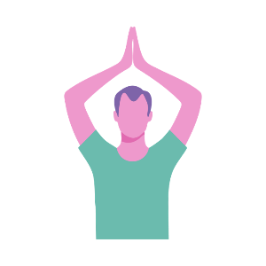
Who has climbed a mountain?
Raise arms up above head or in front of chest and make the shape of a mountain peak.

Jesus sent two disciples
Why do you think he sent two disciples and not one?

It is always best for children and young people to go out with a friend.
Move two fingers to simulate scissors.

He said to them ‘Go to that village and untie the donkey.
If you were a celebrity how would you travel?
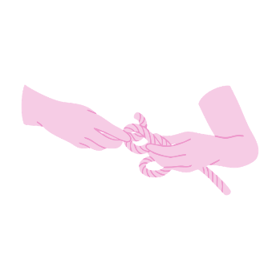
Why did Jesus choose to ride a donkey? He chooses a donkey because it is the humblest of animals and to fulfil a prophesy in Zechariah 9:9 ‘Rejoice greatly Jerusalem, your King comes riding on a donkey’.
Has anyone ridden a donkey?
Have some lengths of rope tied and ask participants to untie it.

If anyone asks what you are doing, tell them the Master needs to borrow it’.
Discuss how you feel about borrowing. Have you ever borrowed something and failed to return it? Have things gone missing?
How do people feel about the phrase ‘Neither a lender nor a borrower be?
It is ok to borrow but we must remember to give something back and look after it. It is good to share the things we have.

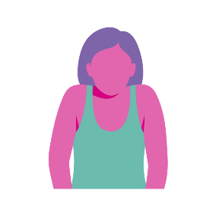
Raise both shoulders up towards the ears.

As Jesus entered Jerusalem crowds of people spread their cloaks on the road.
At the Film Award Ceremonies what is usually on the ground? A red carpet.
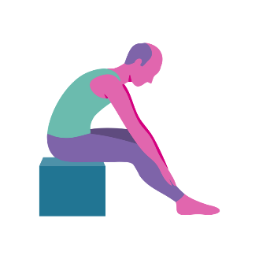
In Tudor times the roads were filthy. Straw would have been laid on the floor for anyone important coming.
Place hands on knees and slowly move hands down the legs towards the feet. Keep legs straight for a better stretch.

Other people spread palm branches and waved them in the air to welcome Jesus to Jerusalem.
Have you ever been part of a huge crowd?
Which celebrities would we like to see?
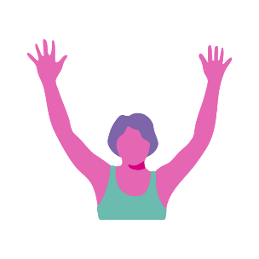
How would we welcome Jesus here today? When we welcome others Jesus said we are welcoming him. It’s important to recognise the good in others.
Place both arms in the
air as if rejoicing.

They shouted ‘Hosanna, Hosanna!’
What would you say if you saw your favourite tv actor or singer?
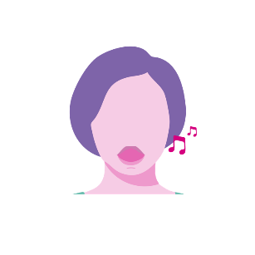
Who is your favourite singer?
Take a deep breath and sing ‘Hosanna’

‘Blessings on him who comes in the name of the Lord’
What is a blessing?
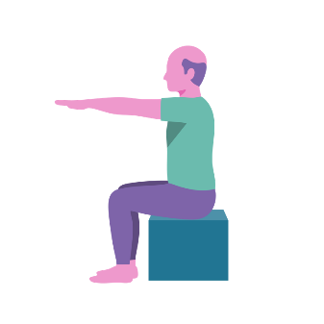
A common phrase we use is ‘bless you!’ What does it mean?
Place arms straight out
in front and hold for the count of 5.

‘Hosanna in the highest heaven!’
They were really pleased that Jesus had come.
Who are you pleased to see? – Parents, siblings, children?
Raise both arms up
in the air and hold.
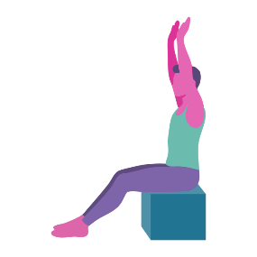

Who is this?’ people asked.
Who was it? - Jesus. Who is Jesus? How has Jesus helped people?

God became man, Jesus. He lived as we do.
He humbled himself to live as we do. He was fully God but also fully human. He asked us to follow him. Christians do this by trying to follow Jesus’ good example.
Turn your head to the left and then to the right as if looking to talk to the people next to you.

Summary
At the time of the Passover it was common for people to sing songs known as Psalms. ‘Hosanna blessed is he who comes in the name of the Lord’ comes from Psalm 118. When do we sing songs? Christmas, birthdays and celebrations. Singing helps to connect people and makes people feel happier. Singing can help us to release emotions, relax and improve our breathing and posture. Does anyone remember what Maria in The Sound of Music did when she was nervous or frightened? She sang.

Prayers
We give thanks for being present today to share in the excitement of Palm Sunday
Help us to remember to be humble
Lord, help us to be confident.
Activities
Make palm crosses
Weaving projects
Explore different types of knots
Quiz on capital cities and facts from around the world
A picture book of iconic buildings from around the world
Have a Sound of Music sing along
Watch the Sound of Music

Good Friday and Easter Sunday
Last week we were with the people of Jerusalem welcoming Jesus into the city with our palm branches. A lot can happen in a week! Today we are going to hear about the events that happened just before Jesus died. The events are shocking and sad but there is good news in the end.
Hymn suggestions
On a hill far away (The old rugged cross)
When I survey the wondrous cross
Christ the Lord is Risen today
John 18:1-19:42 & Matthew 28:1-10, Mark 16:1-8, Luke 24:1-12
Jesus was praying in the garden What is prayer?
Why do people pray?
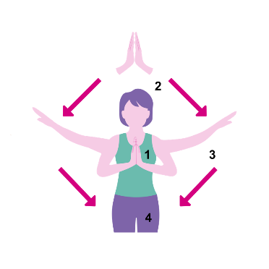
Where do you go when you need to be on your own? Where do you like to pray?
Place hands together in a praying position. Raise your praying hands together as if they are going up to heaven as you breath in. Hold and breathe out as you lower your arms to the side and relax. Repeat twice.

The Chief priests and Pharisees had sent guards with torches and weapons
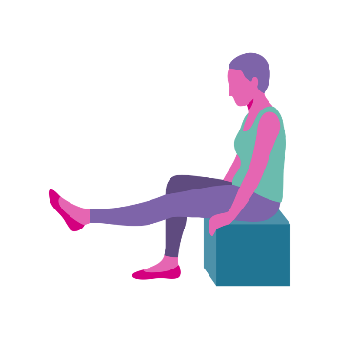
What kinds of weapons do we imagine they had in Jesus’ time?
Why do people have weapons?
Raise one leg straight in front, hold and relax and repeat with the other leg.

Jesus asked “Who are you looking for? They answered “Jesus the Nazarene”. “I am he” he replied.
Who are you? How would you describe yourself?
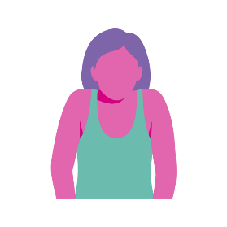
Who did people think Jesus was?
Raise both shoulders towards the ears.

Jesus was taken away and scourged at the pillar.
What forms of punishment have been used in history?
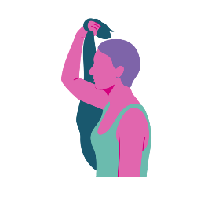
What punishments did people get at school?
Scourge: Take a scarf and use it to whip forward. Repeat three times.

They placed a crown of thorns upon his head, dressed him in a purple robe and ridiculed him.
What does ridicule mean? No one should be made fun of.
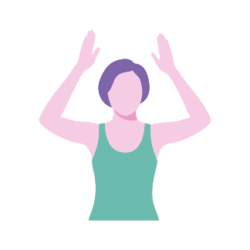
How do you feel when people are laughing at you or calling you names? We should be careful not to make fun of other people. We should all be treated with dignity and respect.
Place both hands to the side of your head and
raise up together as if taking off crown and then placing it back on your head.

The crowds shouted “Crucify him, crucify him!”. Jesus carried his cross to a place called The Skull/ Golgotha. Above his head was written ‘King of the Jews’.
Was he a King?
What sort of King was he?
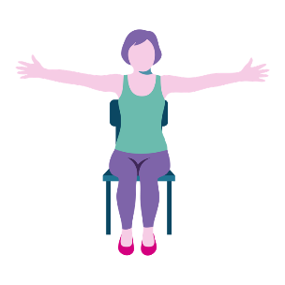
Where is His Kingdom?
Place arms out to the
side as if being crucified on the cross.

They nailed him to the cross and divided his clothes between them.
Show some large nails – if appropriate have a length of wood with some nails semi hammered in for people to hammer in further.
How would it feel to have a nail hammered into your hand?


Make two fists and place them one on top of the other. It may be helpful to say ‘One potato, two potato, three potato, four, five potato, six potato, seven potato more’.

They offered Jesus some vinegar (have some vinegar for people to smell or even some small chunks of bread with some balsamic vinegar on to taste). He bowed his head and gave up his spirit (a moment of silence).
Do you know anyone who has died?
Jesus died – how do you think his mother felt? Discuss feelings of: shock, pain, anger, guilt, sadness/depression.
It’s hard to know what to say when there has been a death. It can be hard to talk about how you feel when someone has died. Drawing a picture can be a helpful way of expressing
your feelings.
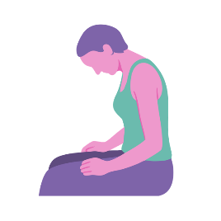
Bow your head forward and relax for five seconds and return to face the front.

The next day the soldiers came and seeing that Jesus was already dead they pierced his side with a sword (take round a crucifix and show this mark on Jesus’ body. The soldiers wanted to make sure Jesus was dead). Joseph of Arimathaea took Jesus’ dead body to a tomb and wrapped the body with myrrh and aloes.
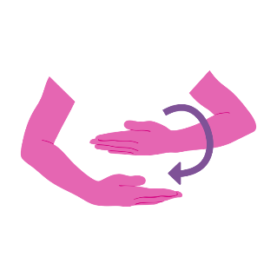
Opportunity to smell myrrh – what did the three wise men bring Jesus when he was born?
What did the gifts mean?
Place one hand above another and roll forward and then roll backwards.

Three days later Mary and her friends walked to the tomb.
Where are your family buried?
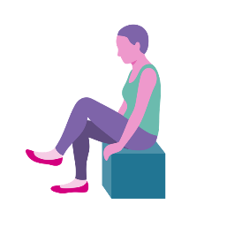
When do you go? How often do you go?
Raise one leg, hold and relax and then raise the next leg, hold and relax. For those more able march ten on the spot.

When they arrived, they saw that the stone was rolled away.
Have you been to visit a grave?
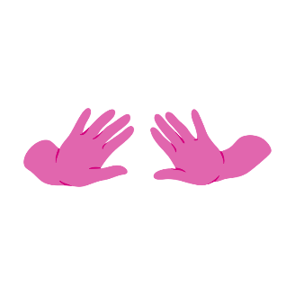
What do you do at a grave?
How would you feel if you went to visit a grave and something was missing?
Place both arms directly
in front of your chest and push the stone out of the way.

An angel appeared. The angel said “Do not be afraid. Jesus is not here, he has risen”
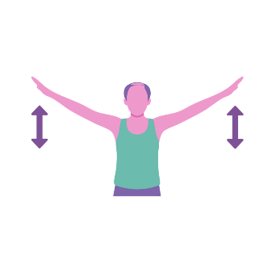
How would you feel if you saw an angel? In Mark it says ‘They were scared out of their wits’.
The angel told them that Jesus was alive again.
Place arms out to the side and flap arms up and down like an angel.

Mary and her friends were so happy to see Jesus again.
When people die do they come back to life?
Christians believe Jesus is God because he came back to life. This is why Christians celebrate Easter.

What do we associate with Easter? (Eggs, chickens, bunny rabbits, daffodils.)
Happy face – smile and open eyes.

Summary
Easter is an important story for Christians because Christians remember the events before Jesus died. Christians remember when he died and celebrate when he rose again. Do you know anyone who has come to life again? How can someone come to life again? None of us have seen Jesus so whether we believe this story depends on our own faith.
What is a role model? We all have role models. Someone we look up to, admire and would like to be like. Who are your role models? For Christians Jesus is the role model. He taught us how to behave well and choose good from bad. This is why people still choose to follow him.
Finally, if Jesus coming alive again is not enough good news it also means that on Easter Sunday we can open our Chocolate Easter Eggs.
Prayers
Thank you Lord, that we have been able to share this story of your life together.
Help us to choose positive role models
We pray for those around the world who are tortured.
Activities
Make and Easter garden on a tray
Explore tools for use with wood – nails, hammer, saw.
Examine role models and what a good role
model is.
Investigate Easter traditions, symbols and
their meanings.
Explore flavours using vinegar and why it is used
for conserving
Use a thesaurus to look up ridicule and practise using sentences with these new words.

About the Author
Having been a Chaplain to individuals living with dementia in a Care Home Setting for 10 years it was evident that there was a need to make Services more meaningful and engaging. Finally movement and scripture were put together. The movement and questions helped engage individuals throughout the service.
Methodist Homes for the Aged asked Yvonne Myers to share her work with colleagues. The Advent and Carol Service Biblical Yoga was used by Care Homes around the UK in 2017. MHA asked Yvonne Myers to write a Guide to Biblical Yoga that could be taken to the National Methodist Conference 2019. There has been a lot of interest in Biblical Yoga from a number of different churches.
Yvonne Myers has put together this book after significant interest and hopes people will feel confident about using it in various settings. Yvonne Myers continues to serve her 40 residents at an MHA Care Home in West Cumbria. Residents take part each week in Biblical Yoga. Yvonne Myers has been asked to speak at Conferences and preach at churches across Cumbria using Biblical Yoga. Biblical Yoga is now being used in a Dementia friendly service in the local community and used as an After School activity at a local primary school.

