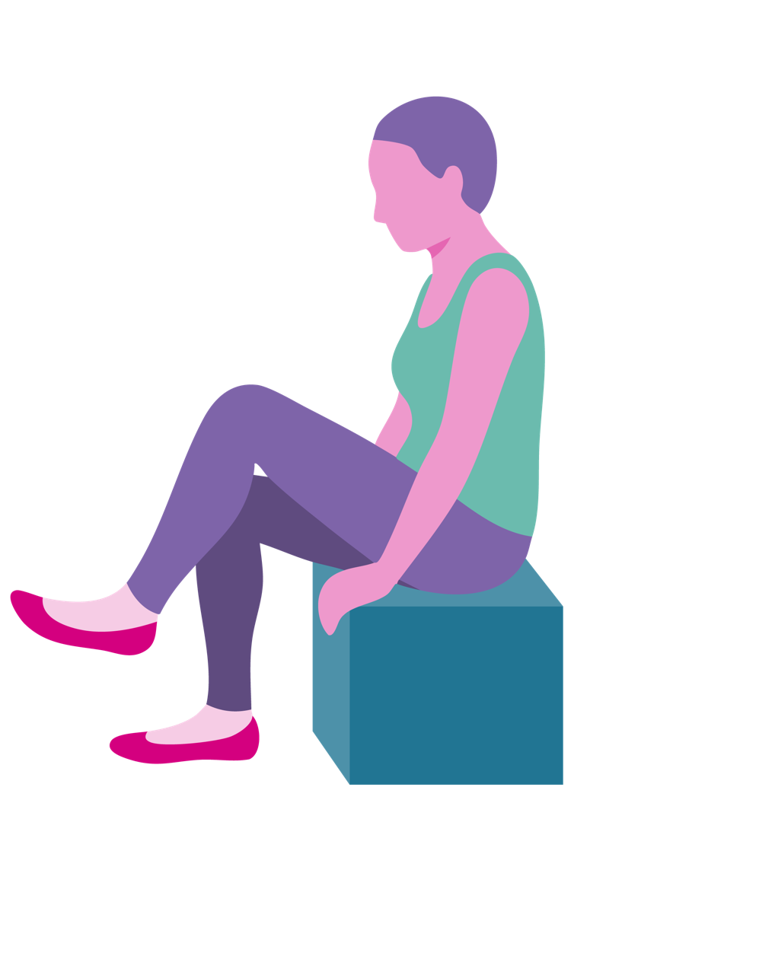

The Winter Blues Wellbeing
Biblical Yoga

Written and developed by Yvonne Myers.

Winter Blues Wellbeing
The decorations are going down and the dark mornings and dark evenings are still with us.
12.5% of the population suffer from winter blues (BBC). Throughout January this series offers an opportunity for residents to take part in a Winter Blues Wellbeing. It will offer an opportunity for residents to share experiences, reminisce,
learn something new, be active and find light
and joy this winter.

Wellbeing is a popular buzz word but King Solomon was the master of wellbeing. He writes:

My child, do not forget my teaching,
Let your heart keep my principles,
Since they will increase your length of days,
Your years of life and your well-being.
(Proverbs 3: 1-2)

Foreword
Biblical yoga is designed to help people with dementia to connect to scripture in the Bible and enable discussion. Biblical Yoga breaks down a passage from the Bible by involving participants with low intensity and low impact movements. The passage is broken down to enable participants to reflect on meaning and give opportunity to express their beliefs and views while also giving opportunities for reminiscence.
People with dementia need to be able to hear the message in that moment and this is done through interaction with the story.

Movement and exercise are an important part of our wellbeing. Breathing exercises increase oxygen levels in the body and have a calming effect. The movement releases the happy hormone endorphin which helps participants to feel happier and endorphins can reduce pain. Each session has a variety of exercises for lower and upper body, using coordination and breathing exercises. The regular exercise helps older participants to stay mobile, more alert, reduces the risk of falls and helps them sleep better at night. Biblical Yoga is low impact and low intensity designed for older and frailer adults and for people with disabilities.

Before You Begin
Ensure Moving and Handling training is complete.
-
Complete a Risk Assessment (See Appendix.)
-
Familiarise yourself with
residents pre-assessments.*
-
Visually check the room for hazards.
The chairs should be set up around the edge
of the room with ample space at each side
but not so far away that people feel
disconnected from each other.
-
Try to use a room that is light and where a window can be opened in warm weather. Consider closing the doors to the corridor if there is likely to be
substantial noise distraction.
-
A carer must be present during the session. You should always ask the Senior Carer if there are any changes to residents’ health that you need to be aware of before the start of each session.
-
Ensure that you speak to each resident before starting the session to ask how they are feeling, whether they are in any pain today and to ask if they would like to take part - consent.
-
To begin the session, explain that how the session will involve doing some movements together and that if anyone feels uncomfortable they should stop that movement. Participants with dementia will need to be reminded of this throughout the session, especially when moves involve arms or shoulders.

*Medical pre-assessments are in Care Plans. Consent forms for taking part in Activities are in the Care Files of residents in Care Homes and Nursing Homes. It is useful to have an understanding of your residents mobility issues so that you can help tailor a movement to their ability. Importantly during these sessions you will not be moving anyone.

When you have a new resident in a Care Home there is an opportunity to visit them 1-2-1 and explain Biblical Yoga. It is then possible to explain the benefits of remaining active while explaining risks (not doing movements that are uncomfortable and taking into account any medical problems).

Begin The Session
Warm up – increasing oxygen intake by singing a hymn. You could listen to a hymn being sung, join in the well known verses and clap hands or use musical instruments. The level of warm up will depend on participants in the group. Biblical yoga
is designed around the needs of the participants and is tailored to suit the needs of older adults
in a seated position.

Main component – the bible reading with actions. There are opportunities for discussion and reminiscence as you read slowly like Lectio Divina and there are opportunities for rest between movements. Once the passage has been read explain that it will be read again and participants can repeat the exercises if they wish.

Demonstrate to participants how to do each movement. Show them how they can do an easier version of the movement. Acknowledge residents for their participation. Correct any bad posture and praise them for their participation. It should be possible to notice when a participant has made a huge effort even if the movement was very small.
Recognising that achievement for that
participant is vital in motivating and
encouraging them to continue engagement.

Throughout the session it is advisable to walk around and engage with participants on a one to one, showing them how to do the moves and making eye contact. Simply holding out hands towards someone will in most cases make that person hold out their hands and then it is possible to encourage movement. At no point is a participant to be pulled or moved. A hand gesture will in most cases indicate to a participant that they should uncross their legs. Remember that you may need to repeat instructions a few times as reaction and response times decrease with age.

Each session has a title followed by the text, which has been adapted from The New English Bible. The words highlighted are the words to do movements to. Pictures of each movement with a description are found alongside each section of the passage. There are suggestions for how many movements to do but each Chaplain will need to consider the ability of their group and gauge how many repeats are appropriate for their residents. There are between 10 and 15 movements per session.

The first session delivered will be new to everyone. Do not worry if participants do not engage with all the movements. They are free to choose which movements they would like to do and at liberty just to watch. As you move through the weeks you should start to notice residents performing the movements more freely. You may like to explain why a movement is beneficial (muscle strength, joint movement, ease neck or back pain, coordination). As the weeks move on you also will become more familiar with the movements and more relaxed about the delivery.

It is recommended that the passage is read again as the Chaplain leads the movements. Participants usually engage with the movements much easier the second time round and it helps to bring the whole passage together for final thoughts.

Cool down – A time of reflection, meditation and/or prayer are all good ways for participants to end a session. Use counting for breathing techniques and imagery from the bible reading as part of the meditation. Refreshments may be offered before further discussion. Use a whiteboard to write down some of the key thoughts and reflections from the passage. Biblical Yoga can be enjoyed by people
of Christian faith and none when done as a stand alone session. I have included suggested prayers, hymns and points for discussion. Depth of discussion will depend on the participants in the session.

On Retreat
Has anyone been on a retreat before? What is a retreat? A retreat is somewhere we go for quiet time. What were your favourite places to go for some quiet space? Religious clergy and laity regularly go on religious retreats. A religious retreat is some time away from normal activities. Time is spent praying and meditating. Where do you like to pray/think? Retreats can sometimes be with other people and can have led reflective sessions. Over the next few weeks we invite you to join some reflective sessions.

Mark 6:31-32
Jesus said to his disciples ‘Come away to a quiet place and rest for a while’ (How long is rest? Rest is as long as it takes? Discuss how much sleep people need? What effects does a lack of sleep have on appetite, temper, patience, mental ability, physical fitness? It’s important to get rest and we need to make sure we get quality rest).
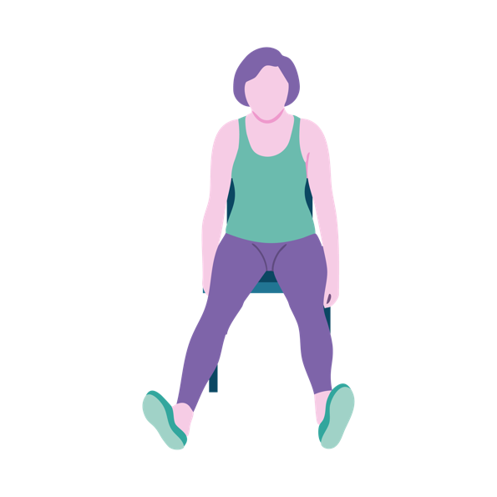 | Raise both legs up straight in front as  if you were putting  your feet up.

They went in a boat to a secluded place.
(Who has been in a rowing boat? How did it feel
to be in the middle of a lake or river? Ask people
for examples of secluded places: a riverbank
for fishermen, a mountain, a forest, a beach.
Do you like being alone?)

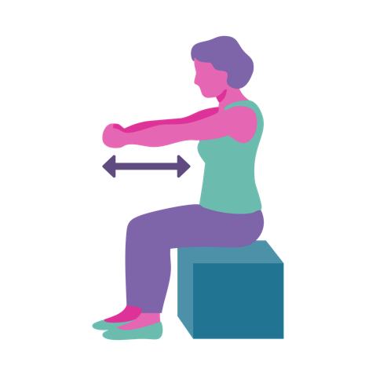 | Hold arms out straight in front and pull them towards you as  if rowing a boat.

People hurried to meet them. (When were you in a rush? Was there a time when you were very busy?)

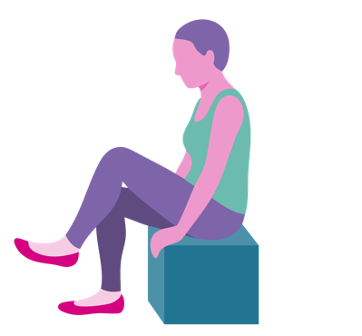 | Raise each leg one at  a time. Hold and relax.  For those more able march on the spot,  10 times, 20 times depending on ability.

The people wanted to hear Jesus teach. (Jesus was inspiring people with his teaching. Did you have a teacher who inspired you? Is there something you would like to learn? Learning keeps our brains active and makes us feel happier (ref), Jesus taught us to keep learning and searching for truth).
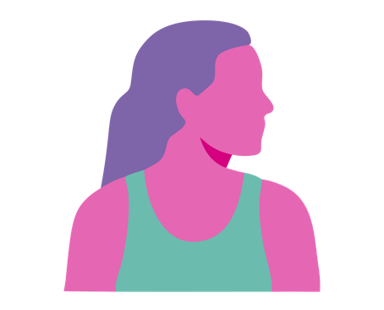 | Look to the right  and look to the left.

The disciples were worried that the people would be getting hungry. Jesus broke the five loaves and two fish and started handing it out. The whole crowd was satisfied. Jesus had fed the five thousand. (The feedings of the five thousand is a famous miracle. Jesus had retreated for a short time on the boat. It was enough time to recharge his batteries. When we are able to switch off the busyness in our minds we find we are capable of far greater things. Sometimes we have to stop our thoughts to make way for new thoughts. We need to clear away the cobwebs to experience some peace and joy.)
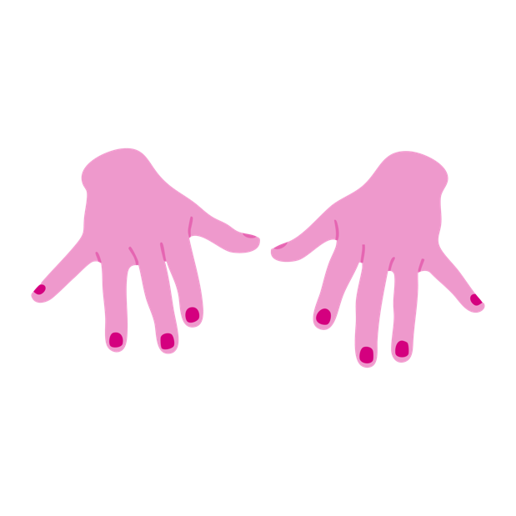 | Arms out in front and twiddle fingers and then shake from the wrist.

Psalm 55:6-8, 16, 17

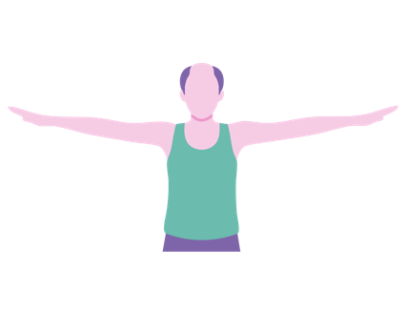 | Who will give me wings  like a dove (If you had wings where would you fly to?)  Action: Arms out to the side and flap them up and down as  if bird wings.
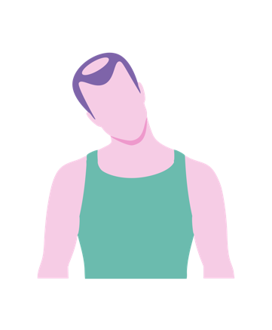 | To fly away and find rest?  (Where is your safe place?)  Action: Tilt head to the right  and then the left.
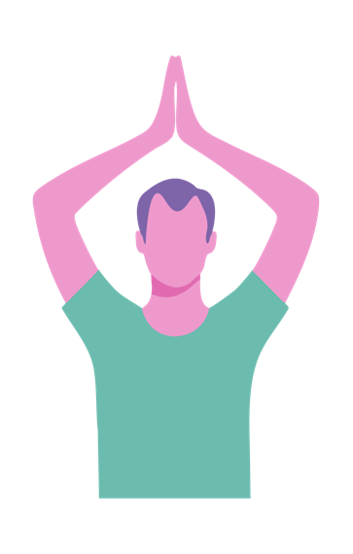 | I would go find my escape and make a home there! (What things do we want to escape from? Bad memories, hurt, pain, tiredness, boredom? Where is that escape?)  Action: Place hands above head or in front of chest to make a roof and make a small twist to the left and then to the right.
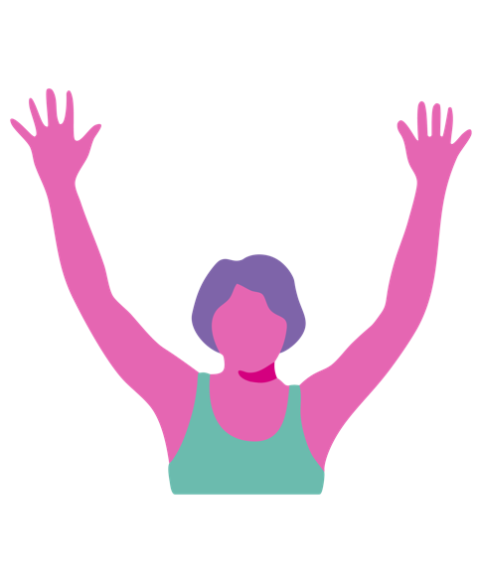 | I would find comfort from the  storm (People are not always aware of the storms in our  heads. It is sometimes difficult  to communicate the thoughts.  Do you have a storm today?)  Action: Raise arms above head of straight out in front and wave arms from side to side like a windy storm blowing above our heads.
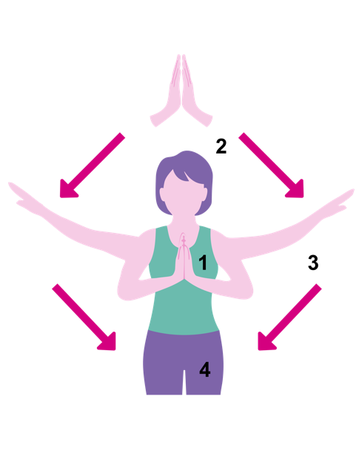 | Morning, evening and night God hears my distress. (Even when we are unable to communicate God hears us. What distresses you? Is anything troubling you today – pain, sadness, longing?)  Action: Prayer position. breathe in and raise arms above head and breathe out  as you lower arms to the side. Do this twice.

Prayers
Dear Lord, we long for peace – peace in the world, peace in our communities, peace in our families
and peace in our minds.

Help us to trust in you Lord and know that
in you we can find shelter and rest.

As we grow older it sometimes becomes more difficult to communicate our feelings. Help us to listen to others even when we cannot understand.

My child, do not forget my teaching,
Let your heart keep my principles,
Since they will increase your length of days,
Your years of life and your well-being.
(Proverbs 3: 1-2)

Hymns
Dear Lord and Father of Mankind
Lord of All Hopefulness
Lord God Your Love Has Called Us Here

Activities
Celebrities go on retreats to practice
mindfulness and indulge in some pampering. Aromatherapy, hand massage, nail painting, meditation, mindfulness colouring,
clay modelling, bird watching.

Who am I?
Today we are going to look at ourselves in the mirror and reflect on who we are and where we have come from. We are going to congratulate each other on all our many achievements, big and small. We are going to look at what makes us special and unique.

1 Corinthians 13:11-13
When I was a child, I talked like and child, saw like a child and thought like a child (What does this mean? What do children have that as we grow
up we lose? – Innocence.)

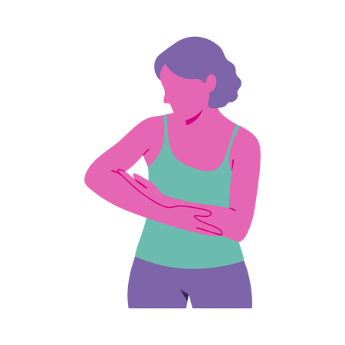 | Rock a baby to  loosen up shoulders.

Now I am an adult and I have finished with my childish ways. (What does it mean to grow up. What things in childhood affect the way we turn out as adults? Talk through some key life events that formed you into the person you are today. Who was the tallest person in the family?).
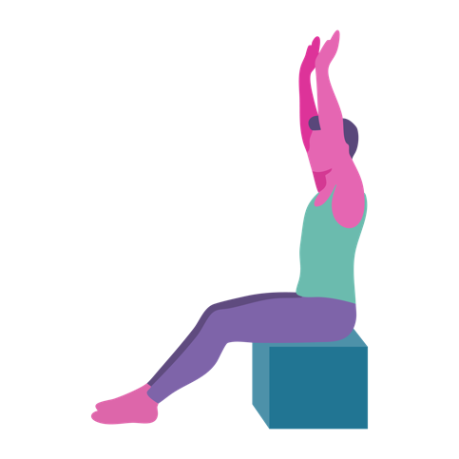 | Start by placing your arms out directly in front of you at the height of  a small child. Slowly  raise arms as high  as is comfortable to  show how we grow  into an adult.

Now we see only reflections in a mirror.
(Take a look at yourself in the mirror. Who do
you look like, your dad, your mum?).

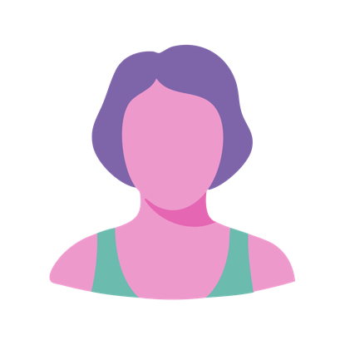 | Take a mirror around the room and ask residents to point to their facial features: eyes, nose, mouth.

Our faces are like riddles (Why are our faces like riddles? Is it possible to say what someone has been through by looking at their face? Can we predict characteristics from looking at someone’s face). Only God knows us by heart.

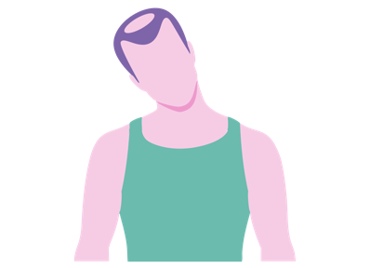 | Do a series of neck movements as if looking at oneself in the mirror.

We seek: faith, hope and love and the
greatest of these is (give residents an
opportunity answer)…love.

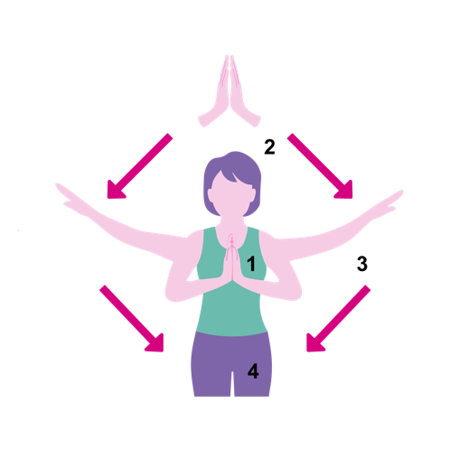 | Start in prayer position for faith. Breathe in and raise arms above head as we have hope and breathe out as you lower arms to the side and bring hands back to prayer position for love. Do this twice.

Psalm 90

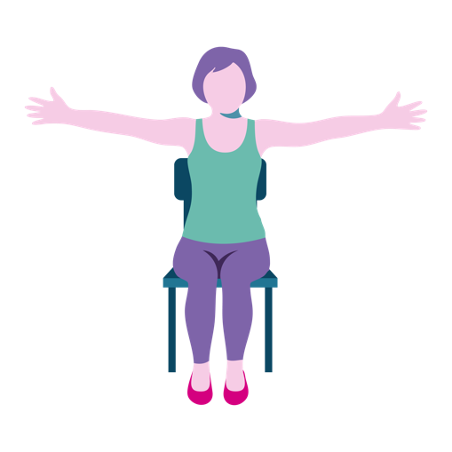 | Lord you have been our refuge from age to age (When are the times you have turned to God for help? Why is it helpful to have a God to turn to?) God is bigger and greater than we can imagine.  Action: Stretch arms out to the side.
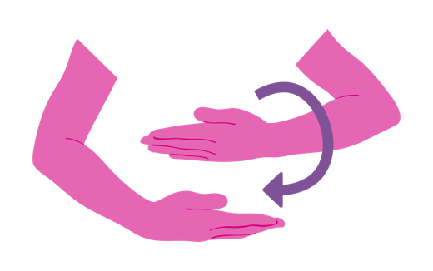 | A thousand years is like a day to God. (Children are eager to grow up quickly and then suddenly we are sat here and wondering where the years have gone. How can time pass so slowly and yet so fast at the same time?)  Action: Roll one arm over another to signify the passing of time.

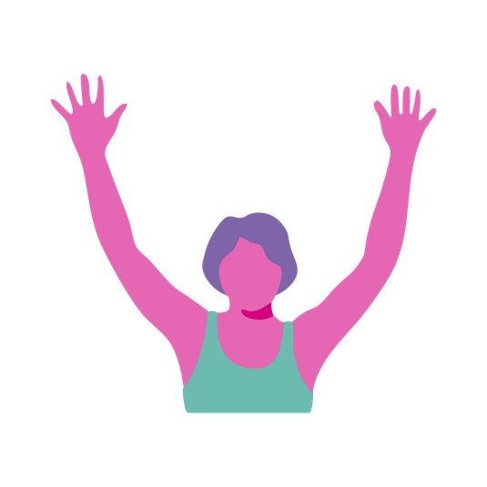 | The span of our life is seventy years, eighty for those who are strong. Who here is over 70? Who here is over 80? Congratulations. Do you know anyone who has had their letter from the Queen for turning 100? How old were your parents when they died?*  Action: Rejoice in your age by raising your arms above your head and then giving yourselves a round of applause.
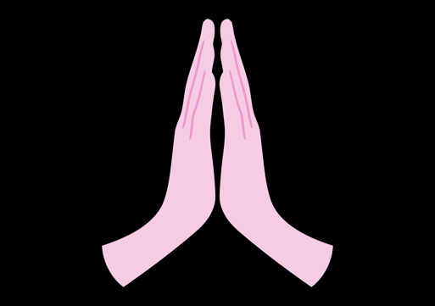 | Rejoice in your years for they have brought wisdom (What are the most important things you have learnt in your life? Can you complete the phrase ‘older and ____ (wiser).  Action: Start with your hands in praying position and then open hands as if opening a book. Reading has long been associated with wisdom. Repeat 5 times.

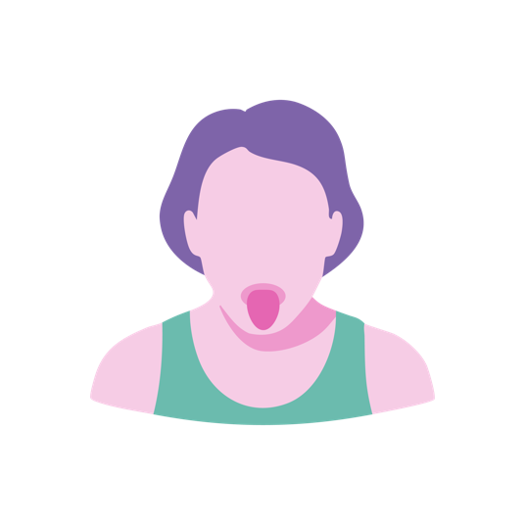 | Each morning fill us with your faithful love. We shall sing and be happy all our days (How do you feel when you wake up? It is a challenge to wake up and feel happy so we ask God to help us to make the most of each new day we have).  Action: Open eyes wide and stretch out your tongue to awaken those facial muscles. This usually makes people laugh. Take a deep breath and have a chorus of ‘lalalala’ for as longas the breath will last.
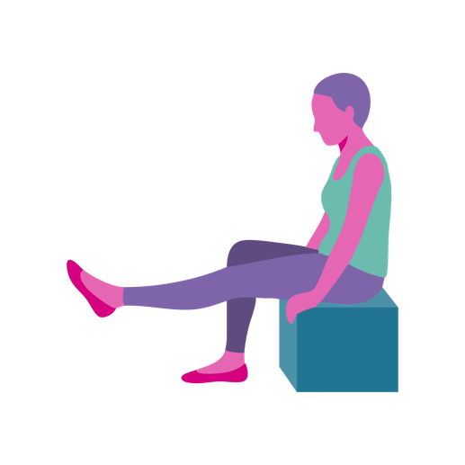 | May the sweetness of the Lord be upon us, to confirm all the work we have done.  Action: Our legs have done lots of work for us. Lift one leg at a time and hold. Repeat as many times as is comfortable.

*If a participant says their parents have not died, ask them how old their parents are. It is not necessary to tell a participant that their parents have died. Help them to work through the reality at their own pace.
Prayers
Today we give thanks for our lives
and thanks for our unique journey.

Be with us Lord as we come to terms with traumatic times in our life. Help us find peace and comfort.

God Grant me the serenity to accept the things I cannot change, courage to change the things
I can and wisdom to know the difference.
(Reinhold Niebuhr– 1892–1971)

My child, do not forget my teaching,
Let your heart keep my principles,
Since they will increase your length of
days, your years of life and your well-being.
(Proverbs 3: 1-2)

Hymns
Abide with me Immortal, Invisible, God only wise
O God the rock of ages

Activities
Prepare some pictures of people and ask residents if they like the look of someone and ask them to describe what they see at face value. Discuss how much difference a smile makes. Meditation: Guided meditation of childhood. Using a mirror ask residents to draw onto the mirror their facial features by copying what they see. Using an easel and a strong light from behind you could draw the outline of the head. Residents can sketch their own faces. Look at childhood photos together. Ask family members to bring in old photos to make into a photobook. This is a good opportunity to contribute to the ‘Personal Profile’ pages in the Care Plan. Riddle quiz.

Let’s Keep Active
Being active helps us to maintain functional independence. Exercise reduces the risk of falls and helps us to sleep better. Being active releases happy hormones called endorphins which make us feel better about ourselves and the world around us. 80% of people aged between 65-74 do not do enough activity and this can contribute to health problems (BHF Statistics 2012).

1 Corinthians 6:19-20
Our bodies are a temple (What does this mean? How should we treat our bodies? How can we take care of our bodies? Other people should treat our body with respect and dignity and it is your responsibility to yourself to speak up for yourself.)

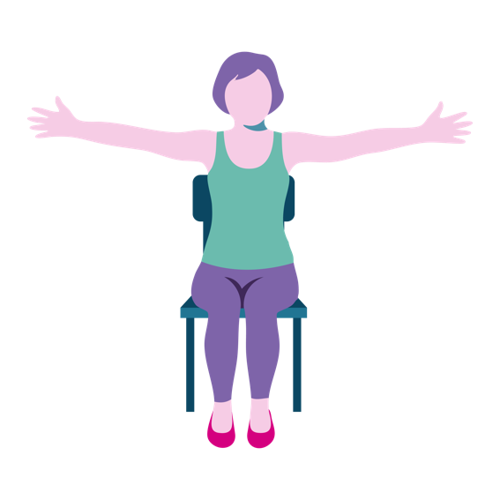 | Hold arms out to the wide and hold for 5 seconds. Be aware of the space that your body is in. Can you feel the chair surrounding you, can you feel the clothes on your  skin, take notice  of your breathing.

The Holy Spirit resides in our bodies (What is Holy Spirit? What makes us different to animals – that we have a soul. The Holy Spirit is a gift from God).
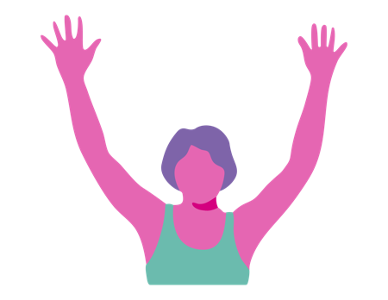 | Raise arms above  head and wave  them side to side.

You are not your own property (God has blessed us with our bodies, mind and spirit and like any gift we have a responsibility to care for and nurture it.
Do you remember your first house?
Did you redecorate? Did you clean your house
and maintain it? Why wouldn’t we do the same
for our own body?)

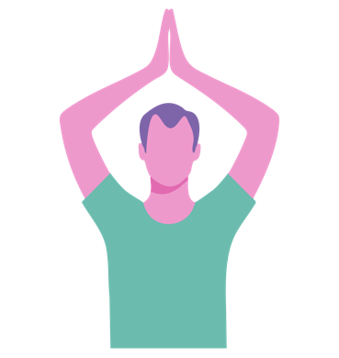 | Raise arms above head and join hands together to make a roof. Make small twists to the left and then the right.

Honour God with your body. (Every effort we make with our bodies, honours God. We walk with someone down the corridor, we smile at someone across the table, we offer someone our newspaper. There are many ways that even in our frailty we can honour God. Taking part in Biblical Yoga and making the effort to join in; this is honouring God).

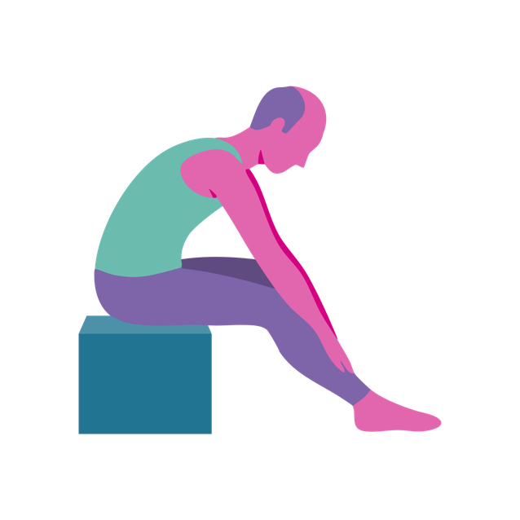 | Place hands on knees and slowly move hands down legs towards feet. This exercise is good for lower back complaints often caused by sitting for long periods of time. When legs are straight  it stretches the leg muscles.

1 Timothy 4:8.
Physical exercise is of value (What regular exercise did you do? Does anyone miss playing sport? Do you miss being part of a team? Exercise releases endorphins known as the happy hormones. We might not be able to do the sports we once did but doing any exercise, including armchair Biblical Yoga has the same good effect. Of the sports people have named, do some actions to match such as swinging arms for tennis, leg kicks for football, marching for walking the dog).

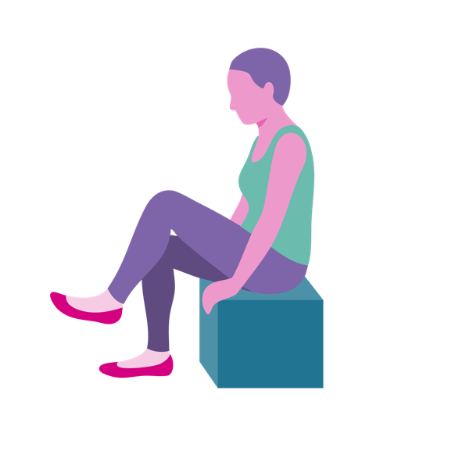 | Raise one leg at a time, hold and relax. For those who are more capable, do leg lift marching. Participants can count with you.  To make this more vigorous you can add arm swings and this will help with coordination.

More valuable than exercise is faith as this holds the promise for both present life and the life to come. (There may be a time when physical movement becomes very restricted. We need faith. Ask residents to explain why faith is important to them – hope, value, love, peace).

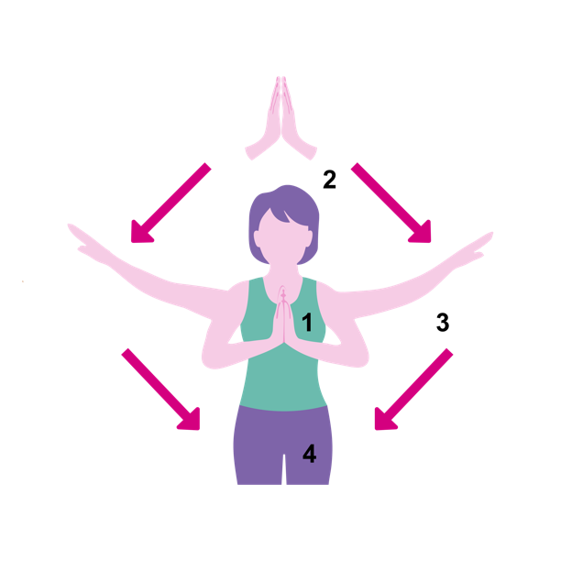 | Hold hands in prayer position. Raise hands up above head and breath in and breath out as arms fall to the side and repeat.

Regular exercise helps us to sleep better, feel less stressed, reduces aches and boosts immune system and give us a better appetite.

Prayers
Lord, it is difficult to accept that as we grow
older there are some physical exercises we
cannot do. Help us to focus on what we can
do and not on what we can’t do.

Give us encouragement each day to take
part in activities that promote our wellbeing.

Help us to accept that you love us for
who we are and what we can offer today.

My child, do not forget my teaching,
Let your heart keep my principles,
Since they will increase your length of
days, your years of life and your well-being.
(Proverbs 3: 1-2)

Hymns
Be still my soul
Give me joy in my heart

Activities
Football game with large blow-up ball in the lounge. Netball game with large blow-up ball. Carpet bowls. Table tennis tournament – take on the Chaplain!

Lifelong Learning
From the moment we are born we are learning. Do we ever stop learning? If you had one wish what would it be? The Lord appeared to Solomon and instructed him to “Ask for whatever you want me to give you.” (1 Kings 3:5) and Solomon replied that he would like wisdom. NHS says that lifelong learning is linked to better mental wellbeing. We want our lives to be satisfying and optimistic. Learning helps to build resilience to depression. Let us hear what Solomon has to say on the subject.

Proverbs 1 – 4

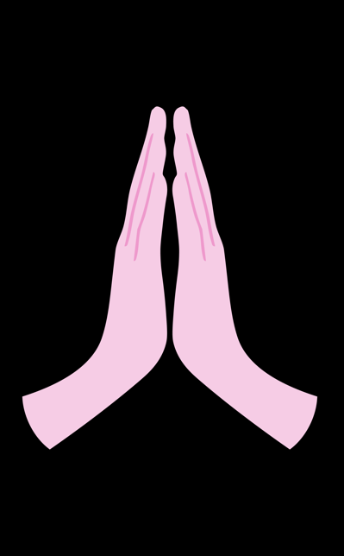 | Solomon wrote that we should learn wisdom, acquired through reading and understanding words. 1: 1-2 (Do you enjoy reading? Was learning to read an important skill? What do you like to read?)  Action: Start with your hands in praying position and then open hands as if opening a book. Reading has long been associated with wisdom. Repeat 5 times.
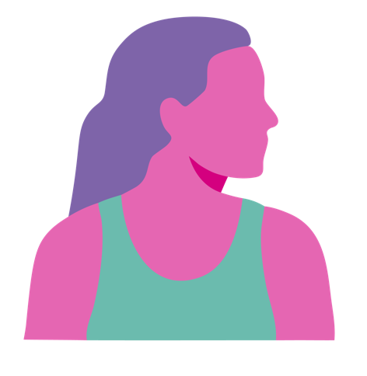 | Let the wise listen and learn more 1:5 (When we listen we learn. Who likes to listen to the radio? We can learn by listening to other people.)  Action: Turn head to the right and then the left as if turning to listen to someone.

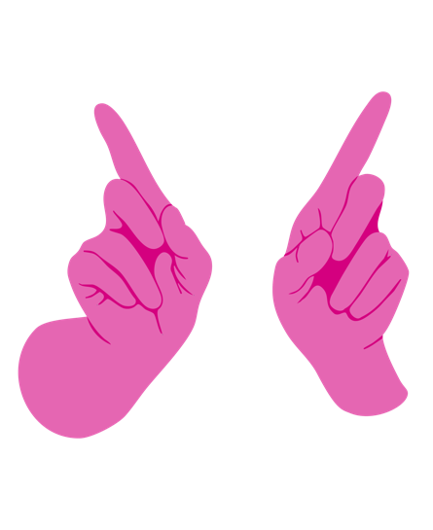 | Listen to your father’s instruction and your mother’s teaching 1:8 (Did your mum and dad give you good advice. What would you ask your parents if they were here today?)  Action: Parents often told us not to do things. Hold your arms out in front and wag your finger. As teenagers we often rebelled but our parents were only wanting the best for us.
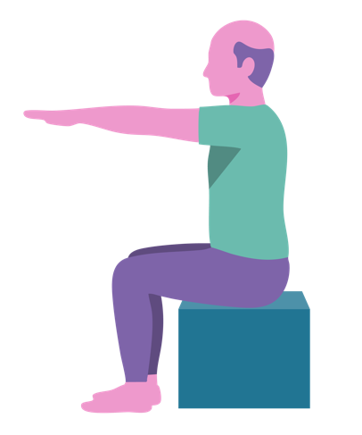 | God is the giver of  wisdom, knowledge and understanding 2:6  (Do you agree? Does faith/religion make us  search for the truth?)  Action: Hold arms out in front as if giving something to someone.

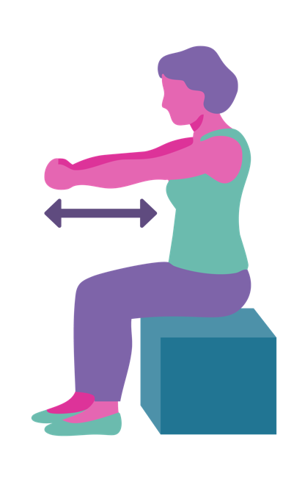 | When wisdom comes into your heart your soul will delight 2:10 (Can you think of a stressful time in your life? When we look back we understand why we were stressed but we now understand the folly and our soul is peaceful).  Action: Hold arms out in front and bring arms in towards the heart. Repeat 3 times.
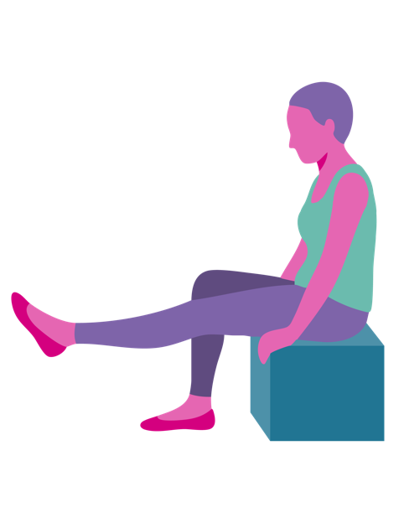 | My child, do not forget my teaching, let your heart keep my principles 3:1 (What are principles? He’s a man of principles. Principles often means a person’s ethics. What ethics have been important to you?)  Action: We often make a stand on principle. Raise one leg, hold and relax and repeat with the other leg. Repeat 3 times.

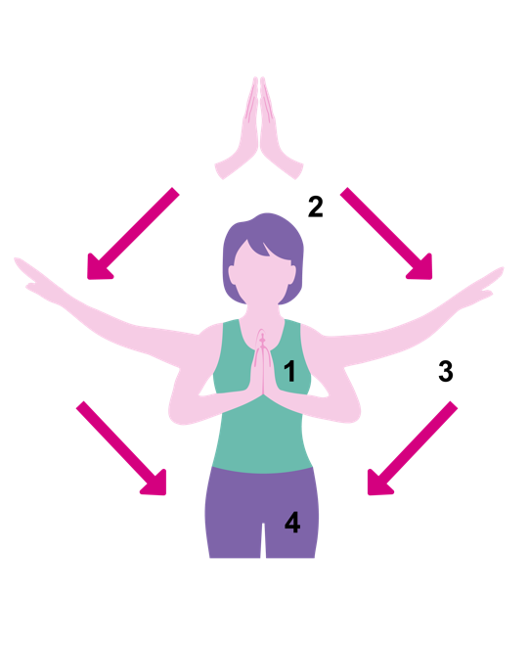 | Learning will increase the length of your days, your years of life and your well-being 3:2 (Research shows that people who continue to learn live longer and happier lives).  Action: Hold hands in prayer position. Raise hands up above head and breath in and breath out as arms fall to the side and repeat.

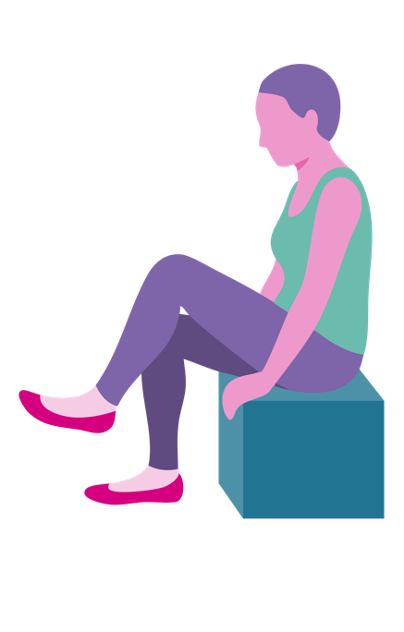 | Accept that there is more still to learn and it will bring health to your body relief to your bones. 3:7-8 (When we have aches and pains it can be all too easy to focus on them. When we are distracted and engaged in an activity or learning something it brings relief. What would you like to learn about? What documentary topics interest you?)  Action: Raise one leg at a time, hold and relax. For those who are more capable, do leg lift marching. Participants can count with you. To make this more vigorous you can add arm swings and this will help with coordination.

Prayers
We thank you for our education.
We thank you that we were given an
opportunity to learn to read and write.

We give thanks for the gift of books
and the joy we have received from reading.

We give thanks for radio and television
which have informed us and kept us
connected to the world around us.

Help us to find new ways of learning as
we have to adapt to failing eyesight and hearing.

My child, do not forget my teaching,
Let your heart keep my principles,
Since they will increase your length of days,
Your years of life and your well-being.
(Proverbs 3: 1-2)

Hymns
Be thou my vision
Praise the Source of Faith and Learning

Activities
Test for hearing. Memory game. Invite in a speaker to talk about something. Bring in some factual books for people to peruse. Bring in some classic childrens’ books that the participants may have
read in their childhood. Have teams and read a concise chapter from a book and ask residents
to name the story.

